TITLE VI PLAN
[SUBRECIPIENT]

Title VI prohibits discrimination in all Federal Transit Administration (FTA) services, programs, or benefits on the basis of Race, Color, or National Origin.
Title VI Program
FTA Circular 4702.1B, Chapter III for FTA Subrecipient:
Title VI Requirements & Guidelines for FTA Recipients at
https://www.transit.dot.gov/regulations-and-guidance/fta-circulars/title-vi-requirements-and-guidelines-federal-transit
The Federal Transit Administration Title VI Circular 4702.1B provides guidance to grantees on how to comply with Title VI regulations. The circular provides specific compliance information for each type of grantee and provides comprehensive appendices including additional guidance and examples to ensure recipients understand the requirements.
By filling out the required fields you are stating that your board of directors, appropriate government entity, or officials responsible for policy decisions and/or approval of board meeting minutes understand the required FTA Circular 4702.1B, Chapter III regulations and agree to adopt all Title VI Program guidelines:
Date: ________________
Title VI Contact Name: _______________________
Title VI Contact Phone: _______________________
Title VI Contact Email: ________________________
Title VI Program Requirements
[Attach a copy of the meeting minutes approving this action.]
Title VI Program Requirement
- TITLE VI AND NON-DISCRIMIINATION POLICY STATEMENT
(Subrecipient) has developed a Title VI and Non-discrimination Policy Statement using the template found on the NDDOT Transit Operator portal for subrecipient use at http://www.dot.nd.gov/divisions/localgov/transit-operator-portal.htm
Insert a short paragraph about where the statement is posted. (transit office/ reception area, website, etc.) If you did not use the NDDOT template indicate so in the paragraph above. VITAL DOCUMENT – TRANSLATE if significant LEP population.
In addition to the policy statement, an abbreviated “Statement of Non-discrimination” has been created using the template found on the NDDOT Transit Operator Portal for subrecipient use at the link posted above and is displayed in all transit vehicles. VITAL DOCUMENT – TRANSLATE if significant LEP population.

- COMPLAINT PROCEDURES/FORMS

(Subrecipient) shall develop complaint procedures and instructions specific to their transit agency. “If information is needed in another language, then contact [phone number]”—should be stated in English and in any other language(s) spoken by LEP populations that meet the Safe Harbor threshold.
Sample Title VI Complaint Procedure
Any person who believes she or he has been discriminated against on the basis of race, color, or national origin by the (Subrecipient) may file a Title VI complaint by completing and submitting the agency’s Title VI Complaint Form.

(Subrecipient) investigates complaints received no more than 180 days after the alleged incident. The (Subrecipient) will process complaints that are complete. Once the complaint is received, the (Subrecipient) will review it to determine if our office has jurisdiction.

The complainant will receive an acknowledgement letter informing her/him whether the complaint will be investigated by our office. The (Subrecipient) has XX days to investigate the complaint. If more information is needed to resolve the case, the (Subrecipient) may contact the complainant.

The complainant has XX business days from the date of the letter to send requested information to the investigator assigned to the case. If the investigator is not contacted by the complainant or does not receive the additional information within XX business days, the (Subrecipient) can administratively close the case. A case can be administratively closed also if the complainant no longer wishes to pursue their case.

After the investigator reviews the complaint, she/he will issue one of two letters to the complainant: a closure letter or a letter of finding (LOF).

A closure letter summarizes the allegations and states that there was not a Title VI violation and that the case will be closed.

An LOF summarizes the allegations and the interviews regarding the alleged incident, and explains whether any disciplinary action, additional training of the staff member, or other action will occur. If the complainant wishes to appeal the decision, she/he has XX days after the date of the letter or the LOF to do so.

A person may also file a complaint directly with the Federal Transit Administration, at FTA Office of Civil Rights, 1200 New Jersey Avenue SE, Washington, DC 20590.

COMPLAINT FORM:

(Subrecipient) has developed a Complaint Form and instructions specific to their transit agency by using the template found in BlackCat Global Resources or on the NDDOT Transit Operator Portal at http://www.dot.nd.gov/divisions/localgov/transit-operator-portal.htm. VITAL DOCUMENT – TRANSLATE if significant LEP population.

COMPLAINT LOG:
(Subrecipient) has adopted NDDOTs Transit Title VI – List of Investigations, Lawsuits, and Complaints, SFN 60805 found in BlackCat Global Resources or on the NDDOT Transit Operators Portal at: http://www.dot.nd.gov/divisions/localgov/transit-operator-portal.htm
The completed form has been attached as part of the plan and will be submitted to NDDOT each year upon request.

- TITLE VI NOTICE TO THE PUBLIC (GENERAL REQUIREMENT)
A Title VI Notice to the Public must be displayed to inform a recipient’s customers of their rights under Title VI. At a minimum, recipients must post the notice on the agency’s website and in public areas of the agency’s office(s), including the reception desk, meeting rooms, etc. Many agencies display their Title VI Notices in transit facilities (e.g., headquarters, transit shelters and stations, etc.), and on transit vehicles (e.g., buses, rail cars, etc.). The Title VI Notice is a vital document. If any of the Limited English Proficient (LEP) populations in your service area meet the Safe Harbor threshold (see Chapter III), then the Notice should be provided in English and in any other language(s) spoken by LEP populations that meet the Safe Harbor Threshold. At a minimum, this statement in the Notice— “If information is needed in another language, then contact [phone number]”—should be stated in English and in any other language(s) spoken by LEP populations that meet the Safe Harbor threshold. See Title VI Non-Discrimination Statement Plaque in BlackCat Global Resources Template or in the: https://www.dot.nd.gov/divisions/localgov/docs/TitleVINon-DiscriminationStatementPlaqueTemplate5-2016.docx

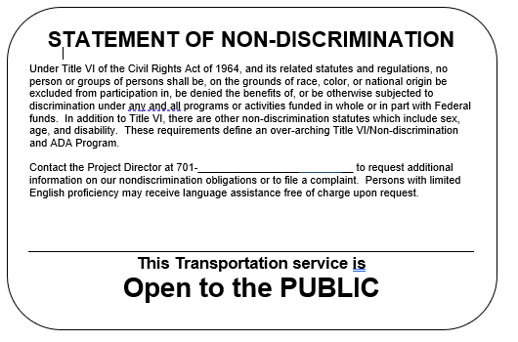

- MINORITY REPRESENTATION ON PLANNING AND ADVISORY BOARDS: (Select One of the options below)
(Subrecipient) has an elected board. (Remove table and description of efforts made to encourage minorities from document)
(Subrecipient) has a non-elected transit related (Indicate type: planning board, advisory councils or committees, or similar bodies, the membership of which is selected by the recipient advisory council, or committee).
- Complete or copy table depicting racial breakdown of the membership.
Board/Council/Committee Name | Caucasian  M/F | American Indian  M/F | Hispanic/Latino  M/F | African American  M/F | Pacific Islander  M/F | Asian American  M/F

- Description of efforts made to encourage participation of minorities: (Outreach efforts include identifying designated minority groups or populations. [E.g.: Native American reservations, minority alliances], and contacting them regarding committee membership. If there are no designated groups or populations in your area indicate so in the description).
- (Subrecipient) has updated their transit related planning board, advisory council, or committee information in the BlackCat System. Download, print, and attach list to this document by using the table above. (All agencies must complete in BlackCat System.)
- MONITORING SUBRECIPIENT: In accordance with 49 CFR 21.9(b), and to ensure that subrecipients are complying with the DOT Title VI regulations, primary recipients must monitor their subrecipients for compliance with the regulations. Importantly, if a subrecipient is not in compliance with Title VI requirements, then the primary recipient is also not in compliance.
a. To ensure the primary and subrecipient are in compliance with Title VI requirements, the primary recipient shall undertake the following activities:

- Document its process for ensuring that all subrecipients are complying with the general reporting requirements of this circular, as well as other requirements that apply to the subrecipient based on the type of entity and the number of fixed route vehicles it operates in peak service if a transit provider.

- Collect Title VI Programs from subrecipients and review programs for compliance. Collection and storage of subrecipient Title VI Programs may be electronic at the option of the primary recipient.

3. At the request of FTA, in response to a complaint of discrimination, or as otherwise deemed necessary by the primary recipient, the primary recipient shall request that subrecipients who provide transportation services verify that their level and quality of FTA service is provided on an equitable basis. Subrecipients that are fixed route transit providers are responsible for reporting as outlined in Chapter IV of this Circular.

b. When a subrecipient is also a direct recipient of FTA funds, that is, applies for funds directly from FTA in addition to receiving funds from a primary recipient, the subrecipient/direct recipient reports directly to FTA and the primary recipient/designated recipient is not responsible for monitoring compliance of that subrecipient. The supplemental agreement signed by both entities in their roles as designated recipient and direct recipient relieves the primary recipient/designated recipient of this oversight responsibility. See Appendix L for clarification of reporting responsibilities by recipient category.

- TITLE VI EQUITY ANALYSIS (ONLY applicable if a new storage facility, maintenance facility or operations center was constructed. If none indicate so.)
a. The recipient shall complete a Title VI equity analysis during the planning stage with regard to where a project is located or sited to ensure the location is selected without regard to race, color, or national origin. Recipients shall engage in outreach to persons potentially impacted by the siting of facilities. The Title VI equity analysis must compare the equity impacts of various siting alternatives, and the analysis must occur before the selection of the preferred site.
b. When evaluating locations of facilities, recipients should give attention to other facilities with similar impacts in the area to determine if any cumulative adverse impacts might result. Analysis should be done at the Census tract or block group where appropriate to ensure that proper perspective is given to localized impacts.
c. If the recipient determines that the location of the project will result in a disparate impact on the basis of race, color, or national origin, the recipient may only locate the project in that location if there is a substantial legitimate justification for locating the project there, and where there are no alternative locations that would have a less disparate impact on the basis of race, color, or national origin. The recipient must show how both tests are met; it is important to understand that in order to make this showing, the recipient must consider and analyze alternatives to determine whether those alternatives would have less of a disparate impact on the basis of race, color, or national origin, and then implement the least discriminatory alternative.
- PUBLIC PARTICIPATION PLAN:
Tri-annually, each subrecipient is required to submit the following as part of their Title VI Plan. For immediate reference please review page(s) 25-26 of FTA C 4702.1B. Additional information can be found on page(s) 20-31 of FTA C 4703.1.
Title VI Public Participation, as required by USDOT Federal Transit Administration, describes the proactive strategies, procedures, and desired outcomes for the subrecipient’s public participation activities.
a. General Information Section (Answer the questions below or write a short paragraph describing. See example below.)
1. Public involvement as a necessity?
2. Why is public involvement necessary?
3. When is public involvement necessary?
4. How does public involvement benefit your transit agency?

Example: Federal and State government mandate public involvement because it helps to guide department decisions in providing public transportation services. Public involvement also benefits [name of subrecipient] and the public by allowing for the development of services that meet the needs of area citizens/customers.
The Federal government mandates public involvement prior to raising fares, implementing major reductions in service, or applying for grants/loans to finance transportation improvement projects.
b. Public Participation/Engagement-Subrecipients have wide latitude to determine how, when, and how often specific public participation activities should take place, and which specific measures are most appropriate.
1. Public Meetings
i. What meetings, if any, are open to the public? (Customer Information Meetings, Advisory Board Meetings, Public Hearings, and other community meetings.)
ii. How do you inform the public of upcoming meetings and agendas? (Newspaper ads, fliers posted, website, social media, etc.)
iii. Do you employ different meeting sizes and formats to accommodate the minority, disabled, and limited English proficiency (LEP) populations? (Describe meeting sizes and formats.)

2. Coordination (Explain what type of coordination was performed in the past 3 years.) (See examples below)
- Other agencies – Department of Labor, Job Service, local churches, local food pantry, medical facilities, social services, educational institutions, and other organizations provide a medium to educate and solicit feedback on current services.
ii. Community events – senior center health fairs, non-profit events, and other community events serve to provide education about your services.
- Interpretation services (Describe what services you use.)

3. Public Studies (Describe your process if you have completed any transit studies in the past 3 years.)
c. As per requirements of [49 U.S.C. Sections 5307(b)] and [5307(c)(I) [subrecipient] will develop and/or consider a process to study public comment before raising a fare or carrying out a major reduction in transportation services.
Subrecipient should consider conducting an annual customer survey. Surveys should be sent to entire community, not just persons already using the transit system.
d. Public Outreach Plan (Answer the questions below or write a short paragraph describing.)
1. How do you advertise? (Possible outreach mediums include local television channels, radio shows or podcasts, social media, and newspaper ads.)
2. Outreach to minority, LEP, and other underserved populations: (The Public Participation Plan should include information about outreach methods to engage minority and limited English proficiency (LEP) populations, as well as a summary of outreach efforts made since the last Title VI Program submission.)
- What steps are being taken to engage in minority and LEP populations?

- What steps are being taken to engage underserved populations such as the disabled or those with low-income?

- Do you schedule meetings at times and locations that are convenient and accessible for minority and LEP communities?

- Do you coordinate with community and faith-based organizations, educational institutions, and other organizations to implement public engagement strategies that reach out specifically to members of affected minority and/or LEP communities? Efforts to involve minority and LEP populations will include both comprehensive measures as well as targeted measures to address linguistic, institutional, religious, cultural, economic, historical, or other barriers that may prevent minority and LEP persons from effectively participating in a subrecipients decision-making process.
d. Type of Public Involvement
1. Who should be involved? It is important to involve as many individuals as possible in order to gain the support and development of public transportation. (List only the types you use in your community.)
• Potential and current riders
• Non-riders
• Business and community leaders/groups
• Government officials
• City Council and other City Departments
• Faith based community
• Academia and educational institutions
• Medical facilities/long term care centers
• Social Service Agencies
• Veterans

(Provide a description of outreach to engage minority, LEP, or other traditionally underserved populations: (e.g.: Native American reservations, minority alliances), limited English proficiency (LEP) groups, or other traditionally underserved populations (group homes, senior centers, nursing homes, etc.), creating mailing lists and disseminating information to groups on the list. If there are no designated groups or populations in your area indicate so in the description.)
(Subrecipient) has adopted NDDOT Sign-In-Sheet form SFN: 59531 for use at public meetings. The form can be found on the NDDOT website at https://www.dot.nd.gov/divisions/civilrights/titlevi.htm under Title VI Forms.
(Subrecipient) has adopted NDDOT Title VI Public Participation Survey form SFN: 60149 as a mechanism for tracking information. This form can be found on the NDDOT website on the https://www.dot.nd.gov/divisions/civilrights/titlevi.htm under Title VI Forms.
- LIMITED ENGLISH PROFICIENCY (LEP) PLAN:
Subrecipients are required to submit a Limited English Proficiency (LEP) Plan as part of their Title VI Program in accordance with Title VI of the Civil Rights Act of 1964, 42 U.S.C. 2000d, et seq, and Executive Order 13166, Improving Access to Services for Persons with Limited English Proficiency. For immediate reference please review FTA C 4702.1B, Chapter III-9.
(Subrecipient) has developed a Limited English Proficiency (LEP) Plan using the template found on the NDDOT Transit Operator Portal for subrecipient use at http://www.dot.nd.gov/divisions/localgov/transit-operator-portal.htm.
NDDOT will assist subrecipient by providing demographic data. The demographic data by county will be placed in the BlackCat System under Global Resources. This information will be updated by NDDOT as needed.

- FIXED ROUTE SERVICE STANDARDS (Only applicable if Fixed Route System. Remove if your agency does not provide fixed route.)
FTA requires subrecipients who are fixed route providers to develop quantitative standards for the following indicators. Standards are to be set by the subrecipient since they apply to each individual subrecipient rather than across the entire transit industry.
- Vehicle load for each mode: Generally expressed as the ratio of passengers to the number of seats on a vehicle, relative to the vehicle’s maximum load point. For example, on a 40-seat bus, a vehicle load of 1.3 means all seats are filled and there are approximately 12 standees. Transit providers can specify vehicle loads for peak vs. off-peak times, and for different modes of transit.

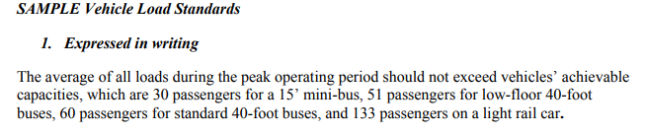
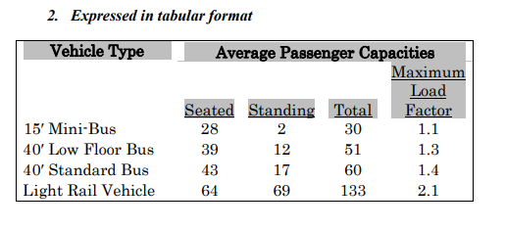

- Vehicle headways for each mode: The amount of time between two vehicles traveling in the same direction on a given line or combination of lines.

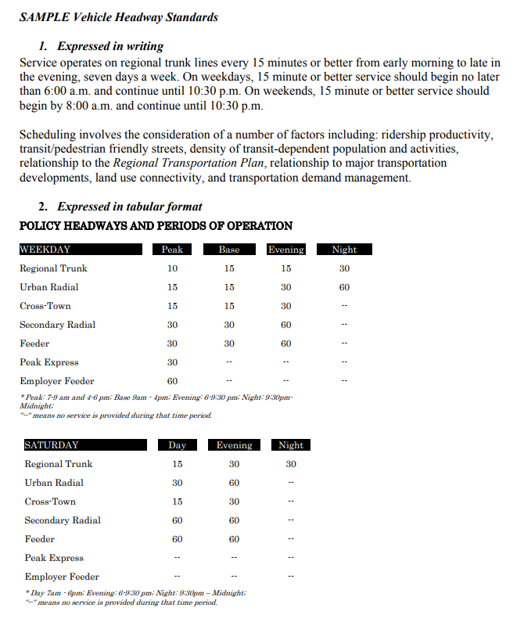
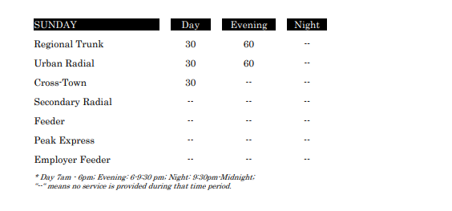

- On-time performance for each mode: A measure of runs completed as scheduled.
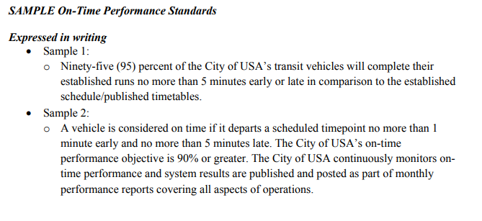
- Service availability for each mode: A general measure of the distribution of routes within an agency’s service area.
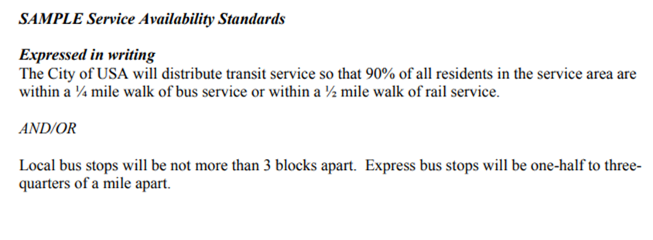
See FTA C 4702.1B, Appendix G for these examples.

