2025
EEO/AFFIRMATIVE ACTION UPDATE
Prepared by
NORTH DAKOTA
DEPARTMENT OF TRANSPORTATION
Bismarck, North Dakota
www.dot.nd.gov
Ronald J. Henke, Director

CIVIL RIGHTS DIVISION
Ramona Bernard, Director
September 29, 2025

Table of Contents
INTRODUCTION 3
Civil Rights Division 3
NDDOT Organizational Chart (08/14/2024) 4
Civil Rights Division Chart (08/09/2024) 5
Updated Policies 6
Policy II 5-1 Title VI/Nondiscrimination and Americans with Disabilities Act (08/14/2024) 6
Policy 2.1 - Title VII/EEO and Workplace Harassment Policy Statement (02/13/2025) 8
Policy 3-1 - Disadvantage Business Enterprise Policy Statement (04/04/2024) 9
Updated Forms 11
PART 1- CONTRACTOR COMPLIANCE 14
I. Organization and structure 14
A. NDDOT EEO Coordinator (External) and staff support 14
B. District or Division Personnel 14
II. Compliance procedures 21
Ill. Accomplishments 21
A. Regular project compliance review program 21
VI. Complaints 22
VII. External training programs, including supportive services 22
A. Participation by women and minorities in construction training programs. 22
VIII. Disadvantaged Business Enterprise Program (DBE) 25
XI. Liaison 25

INTRODUCTION

This document will serve as the 2025 Annual Update to the North Dakota Department of Transportation (NDDOT) five-year EEO/Affirmative Action Plan. The current plan is effective from 2025 through 2028. The entire five-year plan can be found at:
https://www.dot.nd.gov/about-nddot/civil-rights/title-vii-internal-eeo-equal-employment-opportunity-program
This annual update includes data and narratives with regard to the 2025 Workforce Analysis, applicant flow, and a variety of updated statistics.

Civil Rights Division

The NDDOT Civil Rights Division (CRD) is responsible for the following programs:
Title VI/Nondiscrimination and ADA Program
Internal EEO/Title VII Program, including AAR Program
Workplace Investigations Program
Disadvantaged Business Enterprise (DBE) Program,
Including Supportive Services
Contractor Compliance Program
OJT Program, including Supportive Services
Labor Compliance Program, including LCPtracker

NDDOT Organizational Chart (08/14/2024)

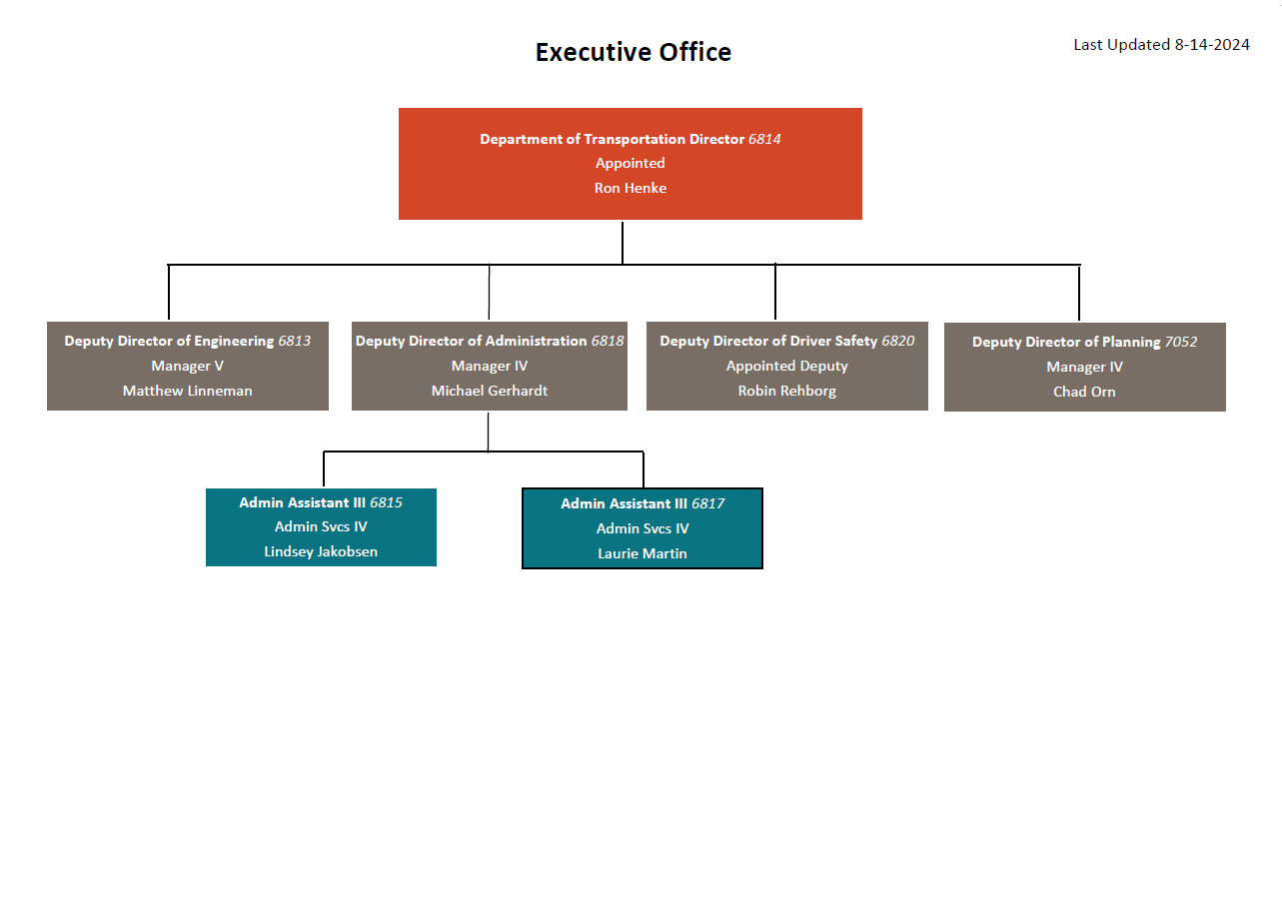

Civil Rights Division Chart (08/09/2024)

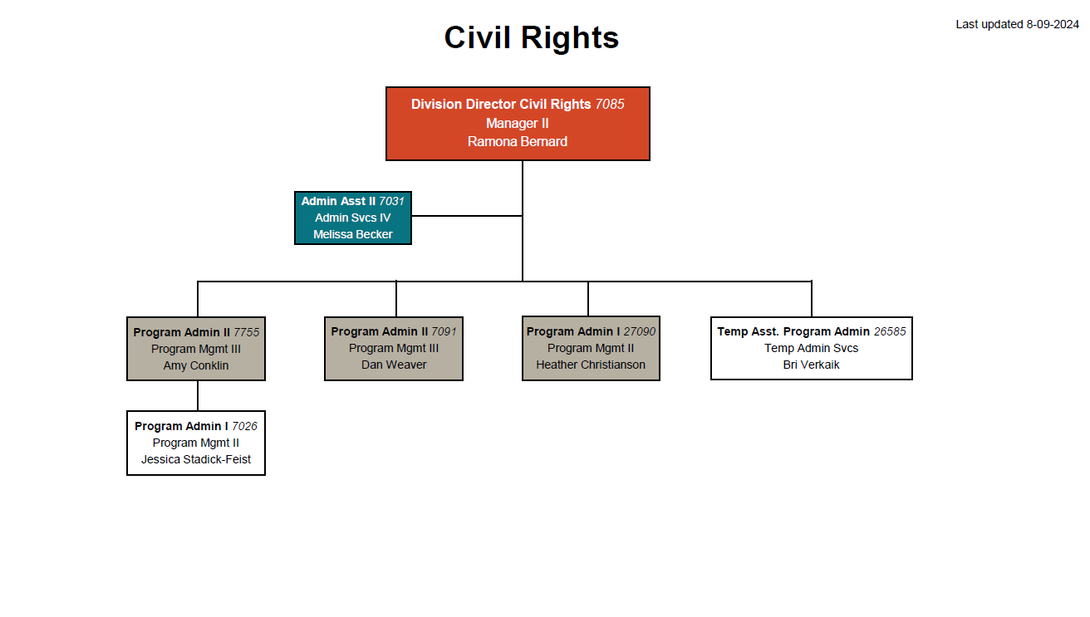

Updated Policies

Policy II 5-1 Title VI/Nondiscrimination and Americans with Disabilities Act (08/13/2024)

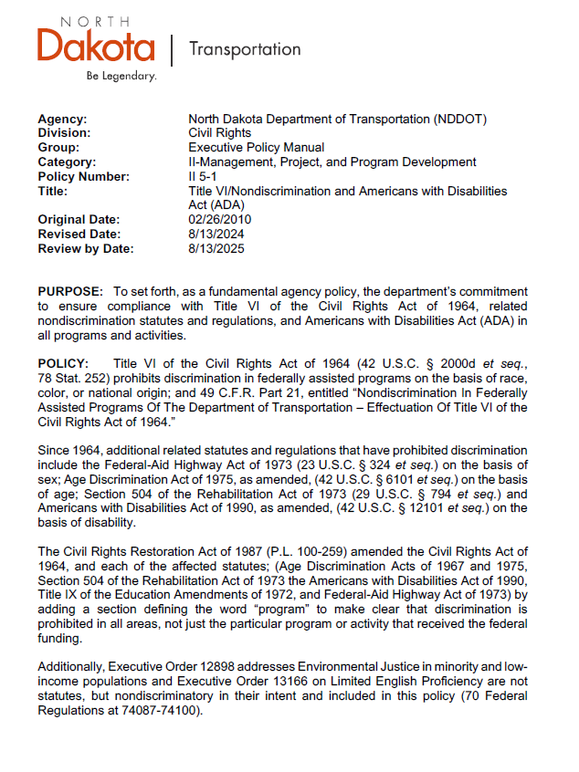
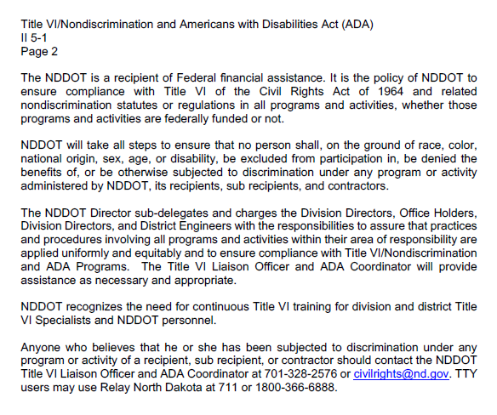

Policy 2.1 - Title VII/EEO and Workplace Harassment Policy Statement (02/13/2025)
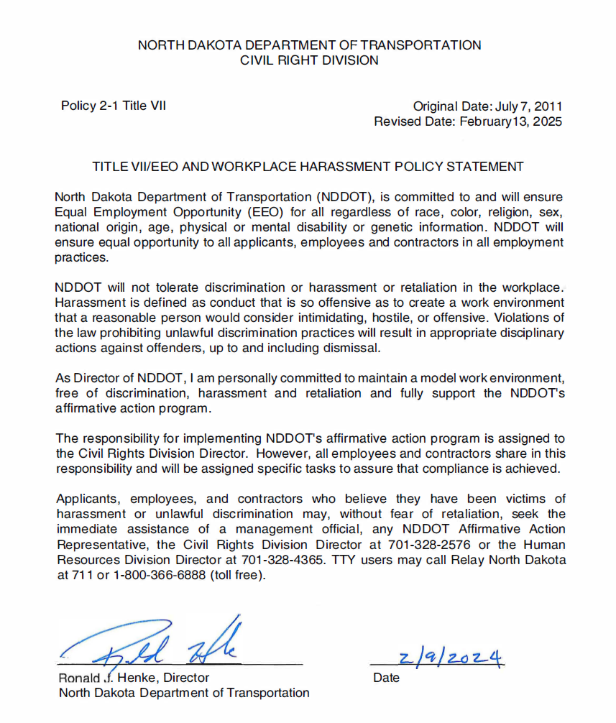

Policy 3-1 - Disadvantage Business Enterprise Policy Statement (04/04/2024)
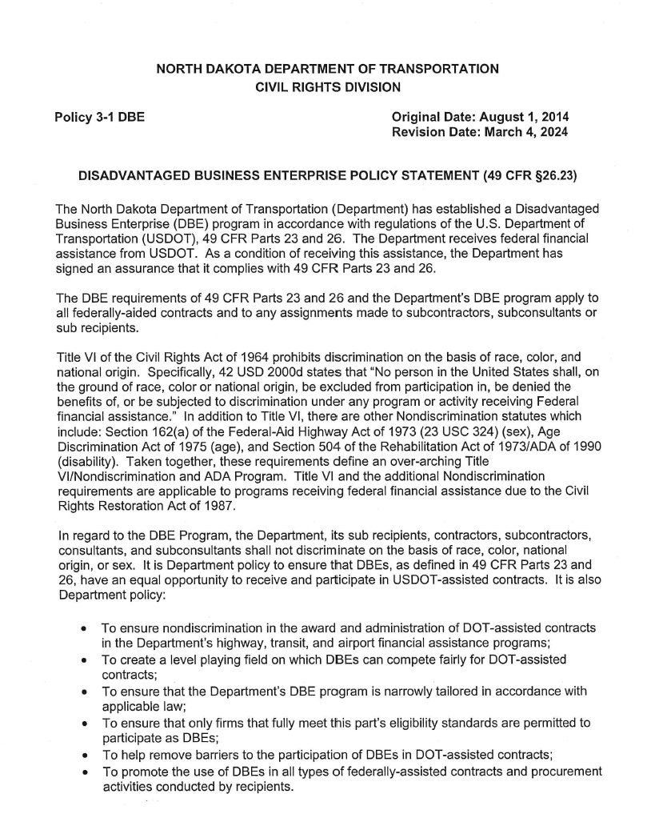
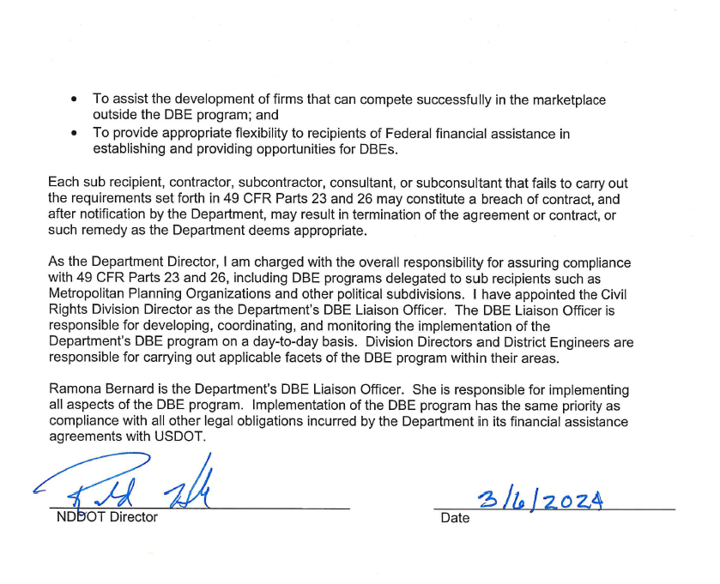

Updated Forms
SFN 51795 – External Complaints of Discrimination (1-2022)
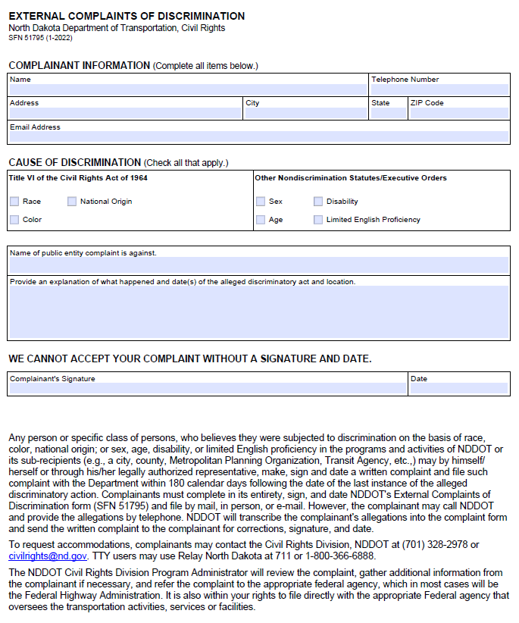

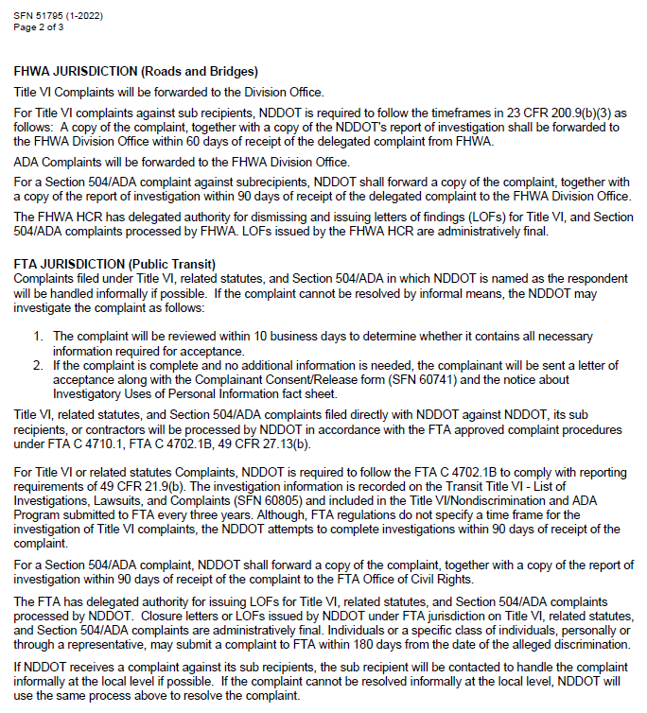
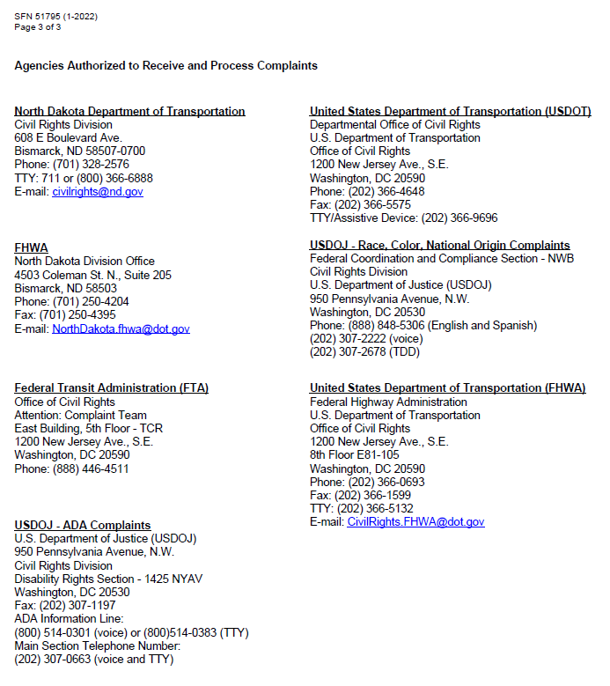

PART 1- CONTRACTOR COMPLIANCE

I. Organization and structure

A. NDDOT EEO Coordinator (External) and staff support

Daniel Weaver is the External EEO Officer and has held this position since May 2020.

B. District or Division Personnel

3. Describe training provided for personnel having EEO compliance responsibility.
External Civil Rights Training for construction personnel was provided virtually thru the TEAMS application, the training included a variety of topics and was held on March 25, 2025. Attendees were required to pre-register for the training and also take a comprehension test at the conclusion of the training session. All construction personnel are required to attend the training. All consultant engineer assignments in LCP Tracker were verified prior to assignment to ensure that they attended the 2025 external civil rights training. LCP Tracker training for Contractors was held on March 31, 2025. The training was recorded and placed on the external NDDOT website so that anyone who was unable to attend, could view the training later.

CRD Staff engaged in training this year as well:

CRD Civil Rights Director Ramona Bernard:

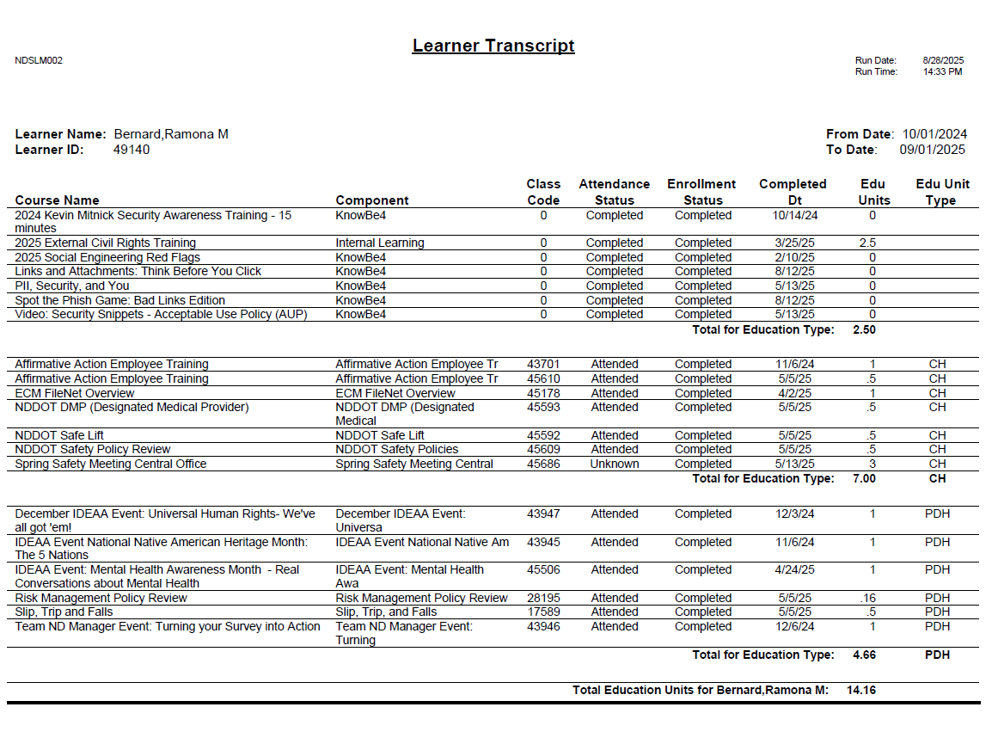
Civil Rights Admin. Heather Christianson:

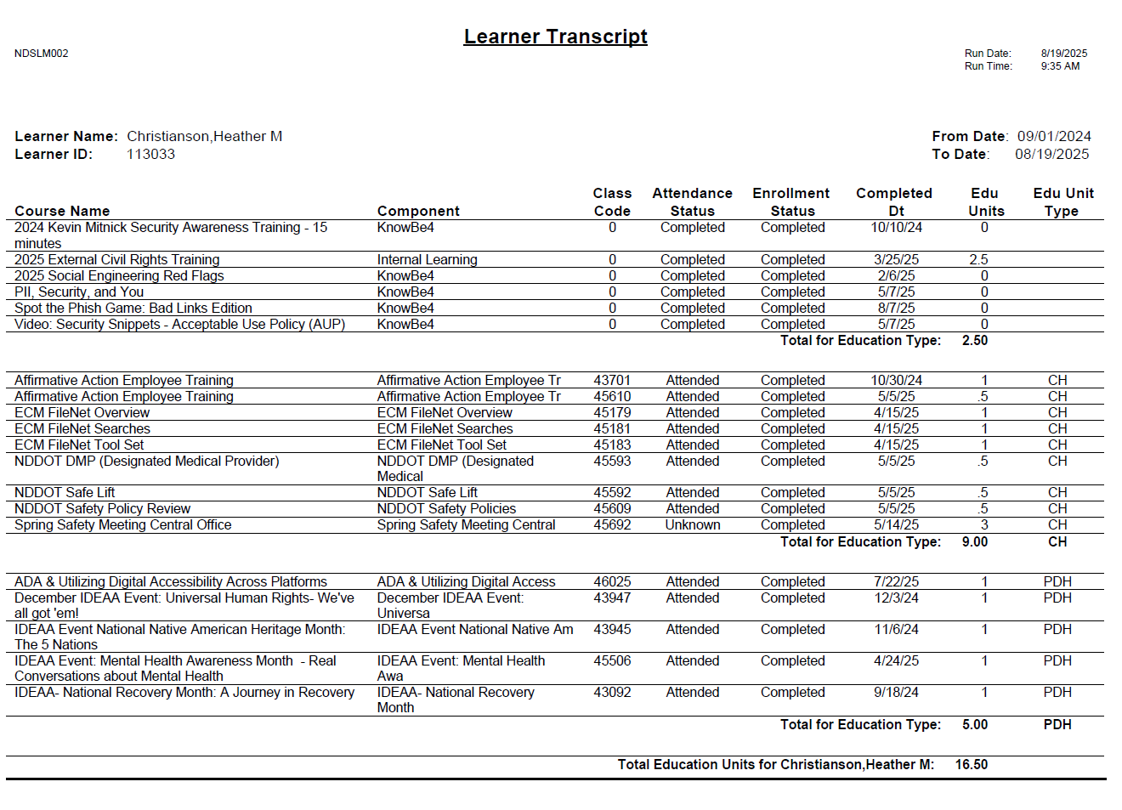

Civil Rights Admin. Daniel Weaver:

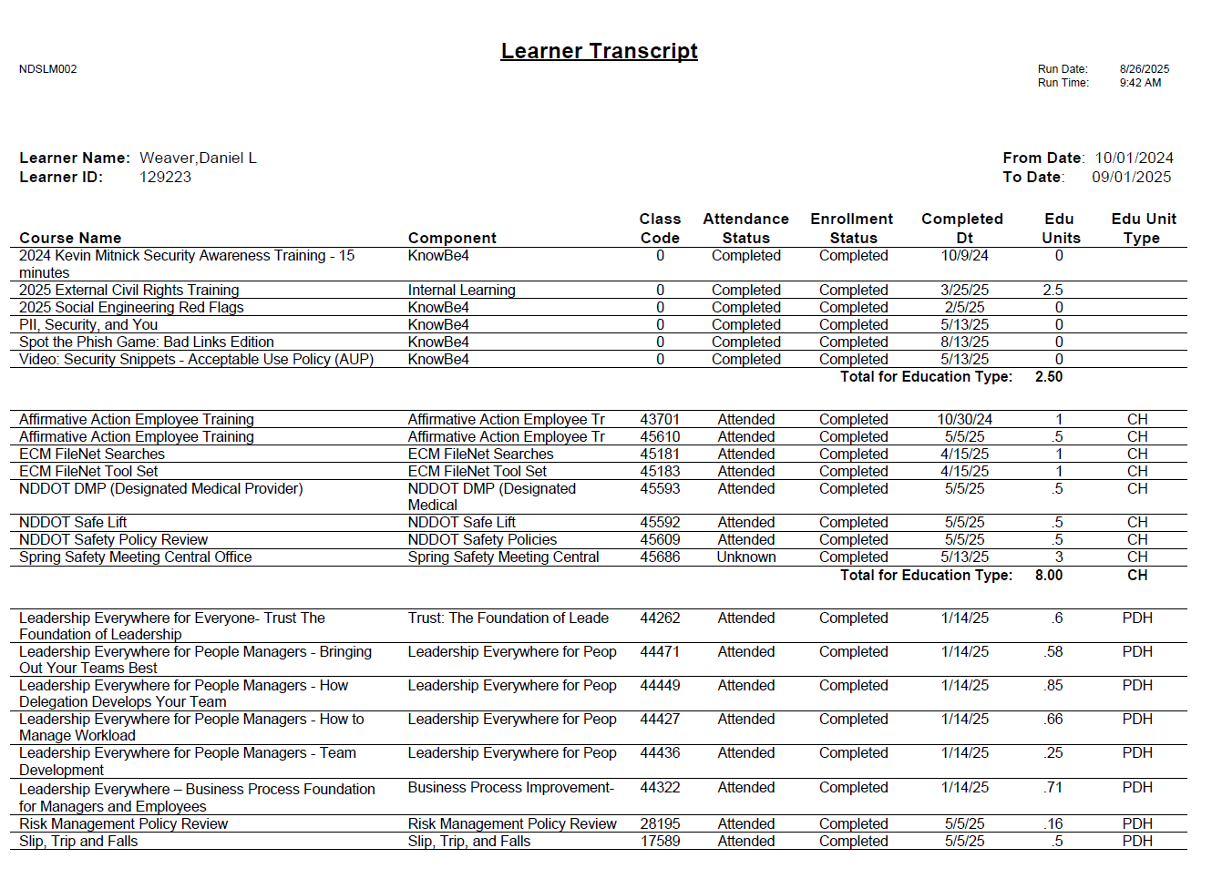
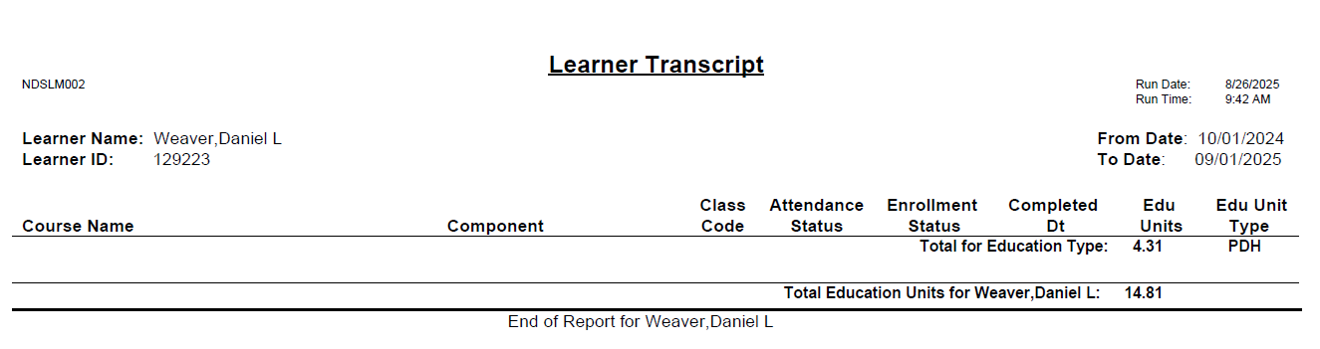

Civil Rights Admin. Amy Conklin:
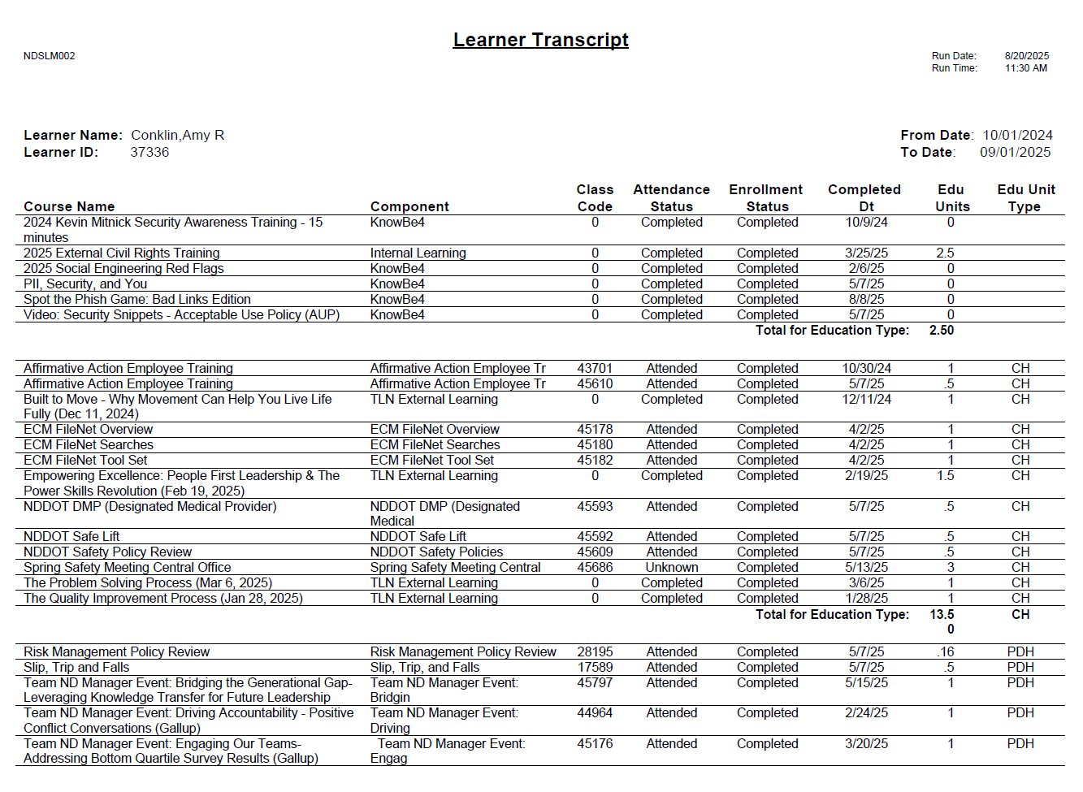
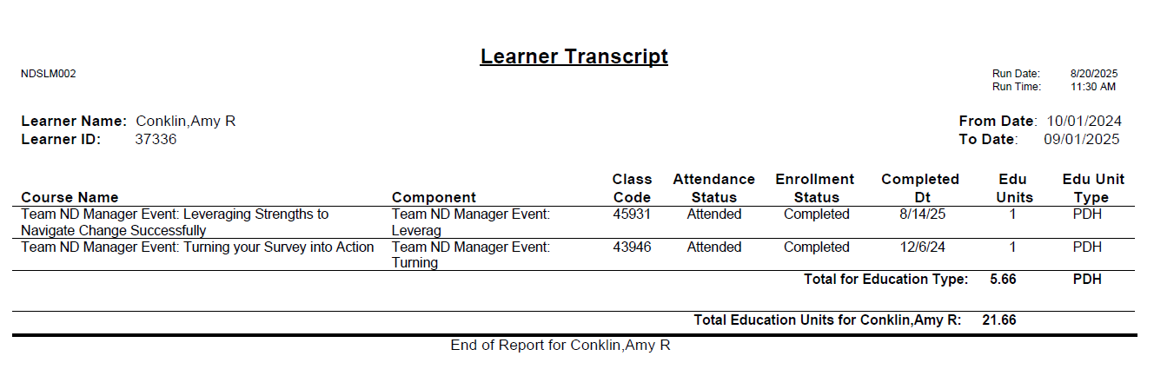

Civil Rights Admin. Jessica Stadick-Feist:
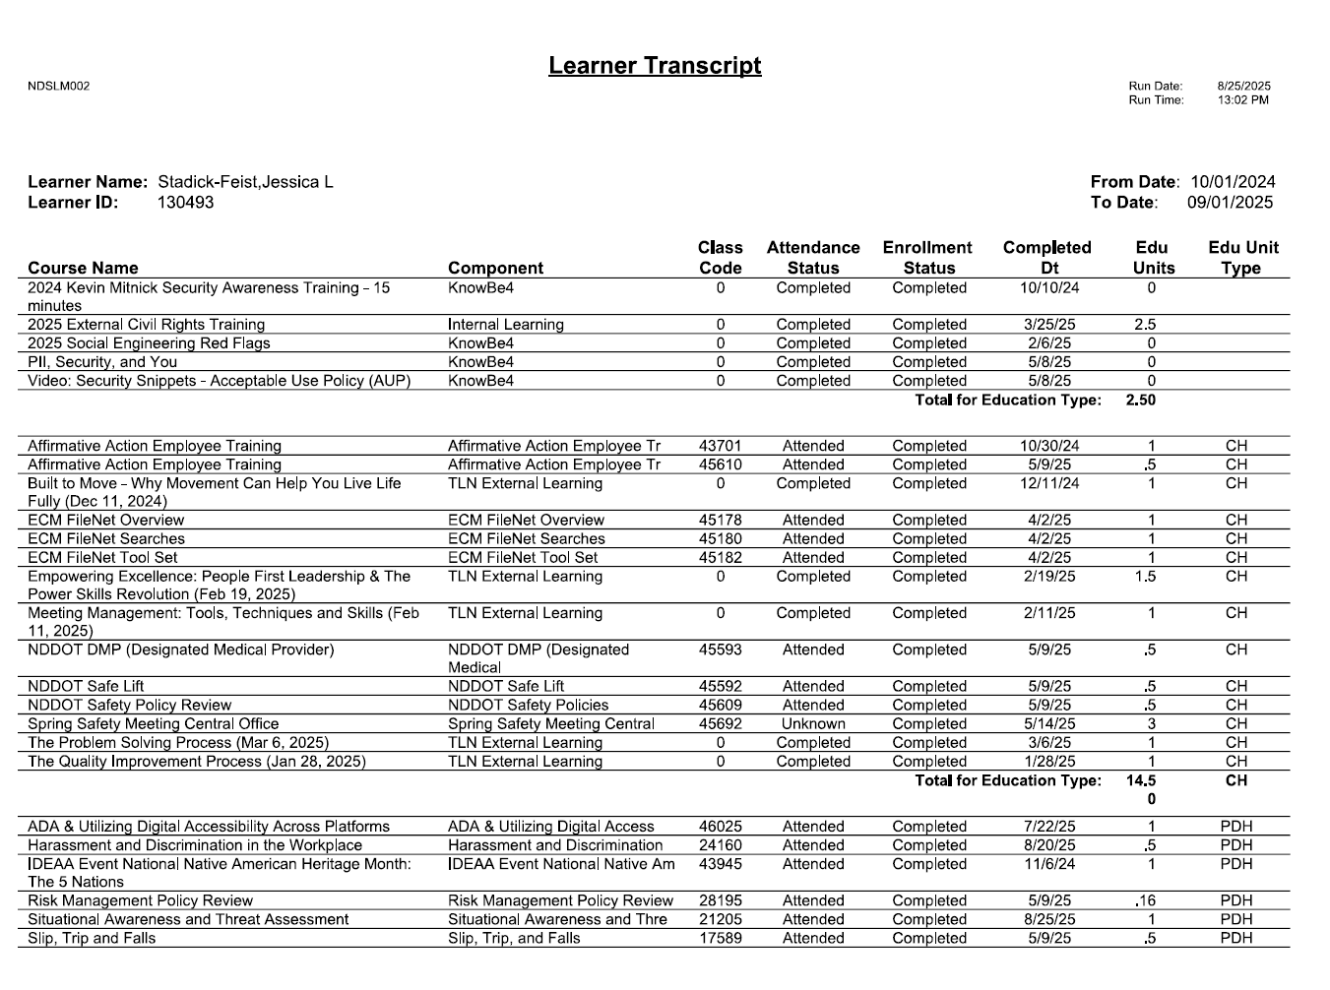
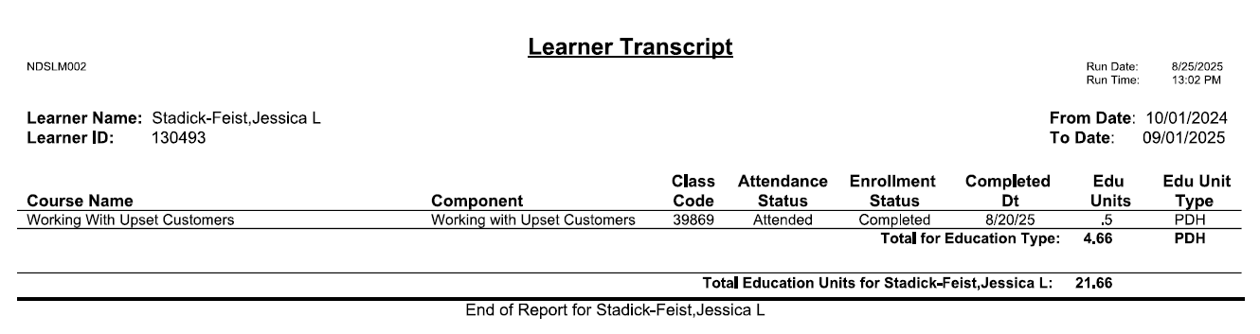

Civil Rights Temp Asst Admin. Bri Verkaik:

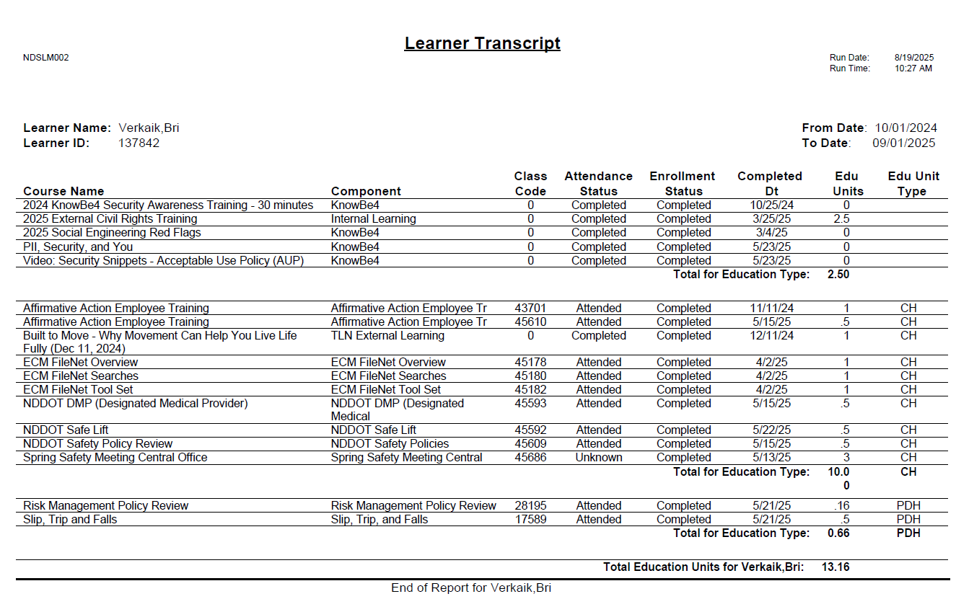

II. Compliance procedures

The Civil Rights Division uses the Certification & Compliance System (CCS), which became mandatory for contractors in October 2017.

CCS combines online tools for contract compliance reporting, payment tracking, applying for DBE Certification, and submitting electronic certified payrolls. Contractors will submit documents and information supporting their Good Faith Efforts after bid openings and will submit all required certified payroll through the system. Contractors/vendors and the Department will be able to communicate with each other easily through the system. The system is based on a partnership between B2Gnow Certification & Compliance System and LCPtracker, a certified payroll tracking firm. Both are national firms that supply business to government online data services.

In 2025, 100% of payrolls were filed using LCPtracker, allowing the NDDOT to track most workers onsite by sex and race/ethnicity and to accurately identify percentages of female and minority workers. This allowed for more advanced Contractor Compliance Reviews in 2025. The system will also allow for easy and efficient reporting of Forms 1391 and 1392.

Ill. Accomplishments

Describe accomplishments in the construction EEO compliance program during the past fiscal year.

Regular project compliance review program

1. Number of compliance reviews conducted | 8
2. Number of contractors reviewed. | 8
3. Number of contractors found in compliance. | 8
4. Number of contractors found in noncompliance. | 0
5. Number of show cause notices issued. | 0
6. Number of show cause notices rescinded. | 0
7. Number of show cause actions still unresolved | 0
8. Number of follow-up reviews conducted. | 0

For 2025, NDDOT set a goal of 9 compliance reviews and completed 8. 1 review was re-scheduled for October 2025 due to weather.
There have been no other changes in this area since the filing of the 2025-28 Plan.

VI. Complaints

Identify the Federal-aid highway contractors that have had discrimination complaints filed against them during the past fiscal year and provide current status.
No discrimination complaints have been filed in fiscal year 2025.

VII. External training programs, including supportive services

Participation by women and minorities in construction training programs.

To follow is a chart of female and minority completions in the 2025 OJT Program:
NDDOT assigned 10 trainees to Prime contractors for the 2025 season. One trainee assignment was waived due to the company being purchased by another company. An additional trainee assignment was carried over from the 2024 season. As of the date of this report the approved trainees have been assigned to 7 minority males and 3 Caucasian males. Of the 7 minority males, 5 were trained as Operators, 1 was trained as a Concrete Finisher and 1 was trained as a Structural Carpenter. Of 3 non-minority male trainees, 2 were trained as Structural Carpenters and 1 was trained as an Operator. NDDOT's OJT Program does not include a training program in the laborer category. At the time of this report 3 trainees have completed training. NDDOT will likely meet our goal of 10 trainee completions by the end of the 2025 construction season.

Trainees | Equipment  Operators | Truck  Drivers | Carpenters | Concrete Masons
Female  Trainees | 0 | 0 | 0 | 0
Minority Male  Trainees | 5 | 0 | 1 | 1
Non-minority male (economically disadvantaged) | 1 | 0 | 2 | 0
Total  Trainees | 6 | 0 | 3 | 1

For 2025, the following represents all participation of females in the contractor workforce, as reported on Forms 1391:

Classification | Total  Workforce | Women  in  Workforce | 2025 % of Women in Workforce | Benchmark as % | % (+) or (-)  Benchmark
Officials | 73 | 24 | 32.88%
Supervisors | 10 | 0 | 0.00%
Foremen/women | 10 | 0 | 0.00%
Clerical | 69 | 66 | 95.65%
Operator | 1307 | 42 | 3.21% | 6.9% | -3.69%
Mechanic | 0 | 0 | 0% | 6.9% | -6.9%
Truck Driver | 885 | 53 | 5.99% | 6.9% | -0.91%
Ironworker | 0 | 0 | 0% | 6.9% | -6.9%
Carpenter | 88 | 2 | 2.27% | 6.9% | -4.63%
Cement Mason | 73 | 1 | 1.37% | 6.9% | -5.53%
Electrician | 120 | 0 | 0% | 6.9% | -6.9%
Painters | 0 | 0 | 0% | 6.9% | -6.9%
Laborer | 2010 | 89 | 4.43% | 6.9% | -2.47%
Apprentices (not OJT) | 1 | 0 | 0% | 6.9% | -6.9%
TOTALS | 4646 | 277 | 5.96% | 6.9% | -0.94%
The contract goal of 6.9% for women set by the Office of Federal Contract Compliance Programs (the OFCCP) is used here as a benchmark. North Dakota federal-aid highway contractors attained a female representation in their workforce of 5.96%.

For 2025, the following represents all participation of minorities in the contractor workforce, as reported on Forms 1391:

Classification | Total Workforce |  | Minorities in  Workforce |  | 2025 % of  Minorities in Workforce |  | Benchmark as % | % (+) or (-)  Benchmark
Officials |  | 73 |  | 3 |  | 4.11%
Supervisors | 10 |  | 2 |  | 20.0%
Foremen/women | 10 |  | 3 |  | 30.0%
Clerical | 69 |  | 0 |  | 13.04%
Operator | 1307 |  | 196 |  | 15.00% |  | 4.4% | +10.6%
Mechanic | 0 |  | 0 |  | 0% |  | 4.4% | -4.4%
Truck Driver | 885 |  | 292 |  | 33.00% |  | 4.4% | +28.6%
Ironworker | 0 |  | 0 |  | 0% |  | 4.4% | -4.4%
Carpenter | 88 |  | 36 |  | 40.91% |  | 4.4% | +36.51%
Cement Mason | 73 |  | 41 |  | 56.16% |  | 4.4% | +51.76%
Electrician | 120 |  | 9 |  | 7.5% |  | 4.4% | +3.1%
Painters | 0 |  | 0 |  | 0% |  | 4.4% | -4.4%
Laborer | 2010 |  | 632 |  | 31.44% |  | 4.4% | +27.04%
Apprentices (not OJT) | 1 |  | 0 |  | 0% |  | 4.4% | -4.4%
TOTALS | 4646 |  | 1214 |  | 26.13% |  | 4.4% | +21.73%

North Dakota’s minority participation is greater than the OFCCP benchmark goal of 4.4% (or less) set in the contract special provisions. NDDOT acknowledges it has no authority to enforce OFCCP goals. They are used here only to provide a basis of comparison. Minority participation met the benchmark goal in most categories and met the goal overall.

VIII. Disadvantaged Business Enterprise Program (DBE)

Goal-setting for disadvantaged business enterprises (DBEs) with capabilities in the transportation industry is required by 49 Code of Federal Regulations Part 26. The following goals are applicable for the 2025 federal fiscal year (October 1, 2024 through September 30, 2025).
2021-2023 FEDERAL HIGHWAY ADMINISTRATION DBE GOAL: 3.48% Percent
This goal represents the percentage of work to be accomplished by DBE prime contractors, subcontractors, consultants, vendors, and material suppliers on federal-aid transportation projects.
NDDOT’s FHWA 2024-2026 Goal Setting Methodology is posted on the Department’s website at: https://www.dot.nd.gov/sites/www/files/documents/civil-rights/FHWA-FY-2024-2026-Goal-Methodology.pdf

XI. Liaison
Describe the liaison established by the State between public (State, county and municipal) agencies and private organizations involved in EEO programs. How is the liaison maintained on a continuing basis?
FHWA Sub Recipients
Currently, sub recipient federal-aid projects are let by NDDOT and subject to the requirements of the Contractor Compliance Review Program. When a sub recipient’s prime contractor is selected for a compliance review, Civil Rights Division sends a notice of review letter to the prime contractor with a copy to NDDOT’s Assistant District Engineer. A representative of the city or county is invited to participate in the process, if applicable.
Additionally, NDDOT has developed a process to conduct Title VI reviews of sub recipients (Metropolitan Planning Organizations, cities, and counties). Title VI Specialists are responsible to conduct Title VI pre-award and post-award compliance reviews of their program area sub recipients.

Pre-award compliance reviews require applicants for federal financial assistance to identify all the components necessary to develop a Title VI Plan including EEO and ADA requirements. The Title VI Specialist provides one-on-one training and assistance to the applicant to develop their Title VI Program. The Title VI Sub Recipient Information web page provides templates and information for the development of Title VI, EEO, and ADA program documents. For pre-award, the Title VI sub recipient is required to submit their signed Title VI Assurances document, signed Title VI/Nondiscrimination and ADA Policy Statement, and the sub recipient Title VI Checklist. The Title VI Specialist reviews these documents for the pre-award compliance review.
Post-award compliance reviews require ten percent of sub-recipients to be audited or a minimum of one sub recipient per division or district must be reviewed annually. Sub recipients selected for post-award reviews are required to produce all the documentation of all the components of the sub recipient’s Title VI Plan. The Title VI Specialists conduct on-site reviews for post-award compliance.
NDDOT Title VI/Nondiscrimination and ADA Program has Review Selection and Procedures that are a step-by-step guidance from pre-award through post-award compliance including corrective action within specified timeframes.
During the period between July 1, 2024, and June 30, 2025, NDDOT had one division and no districts with sub recipients.
Local Government Division had a total of four sub recipients for federal highway funds. These four sub recipients are the same every year. We have audited all of them previously, so we know they have a Title VI/Nondiscrimination and ADA Program. New sub recipients or sub recipients from past years require the pre-award compliance review.
Sub recipients are randomly selected for annual reviews in the year in which the project is to be constructed or for funds used on other eligible activities. Ten percent of the available pool or a minimum of one review will be conducted in the year the project is constructed.
The Title VI Specialist conducted one Title VI review. This review was conducted on Fargo Metro COG MPO, who also received FTA funds.
Title VI review criteria includes personnel employed, composition and selection of commission, council, committee, and boards, recruitment, and internal and external outreach. Findings will be provided to Bis-Man MPO for their review, response, and revision after their final documentation is reviewed.

OTHER GENERAL COMMENTS
The Title VI criteria has been modified to prevent the repeated review in subsequent years of subrecipients for which prior reviews have not revealed deficiencies. The exact wording is as follows:
- NDDOT sub recipients
  - All sub recipients will complete a pre-award Sub Recipient Audit Checklist.
  - Sub recipients shall be randomly selected for review in the year in which the project is constructed. Ten percent of the available pool or a minimum of one review will be conducted in the year the project is constructed. If a sub recipient is selected in subsequent years, provided no deficiencies were identified in the previous audit, a new sub recipient will be selected for review.
If deficiencies are found during the review, the sub recipient shall be reviewed the following year
ADDITIONAL SUB RECIPIENT REVIEWS – FTA Reviews-Transit Agencies
FTA Circular 4702.1B Requirements
Local Government, Transit Section, is required to audit 10% or a minimum of three of Transit Providers that receive 5310, 5311 or 5339 federal funds. 4 transit providers were selected for review.
- Transit Section had a total of 28 sub recipients that received 5310, 5311 or 5339 federal funds, therefore 3 transit providers were required to be audited. A total of 3 audits were performed in 2025.

