*REMOVE these instructions and all red text before sending out this letter. Modify text for areas highlighted in yellow below. Choose either paragraph A or B and delete the other. Choose either paragraph C or D and delete the other. See the attached map and contacts for the appropriate Wetland Management District or Wildlife Refuge in which to send the letter. If your project covers more than one district please send a letter to each district the project will occur in. You do not need to mail the Wetland Management District contacts or map with the letter.

Month dd, yyyy

«CTitle» «First» «Last»
«Title»
«Department»
«Agency»
«Address»
«City», «State» «Zip»

PROJECT NO. (Project Number), PCN (Number)
(DESCRIPTION) -all caps
(COUNTY) -all caps

Paragraph A (to be used for Interstate, US, or State highway projects) – The North Dakota Department of Transportation, in cooperation with the Federal Highway Administration, is proposing a roadway improvement on (Highway Name, Vicinity, Description).

Paragraph B (to be used for Urban and County Federal Aid Route highway projects) – (Local Government Agency replace with the appropriate City or County), in cooperation with the North Dakota Department of Transportation and Federal Highway Administration, is proposing a roadway improvement on (Highway Name, Vicinity, Description).

The project consists of (Scope of Work).

This project is expected to be constructed during the yyyy construction season.

Paragraph C (if right-of-way will be required) – The project will require permanent and/or temporary right-of-way. The right-of-way required will be (explain where it is in relation to the project, i.e. in linear strips parallel to the project area).

Paragraph D (if right-of-way will not be required) – The project will not require the acquisition of permanent or temporary right-of-way.

To ensure that all social, economic, and environmental effects are considered in the development of this project, we are soliciting your views and comments on the proposed project pursuant to Section 102(2) (D) (IV) of the National Environmental Policy Act of 1969, as amended. We are particularly interested in any Service Interest property within a ½ mile of either side of the proposed roadway improvement. Any information that might help us in our studies would be appreciated.

Page 2
Month dd, yyyy

It is requested that any comments or information be forwarded to our office on or before (mm/dd/yyyy). If no reply is received by this date, it will be assumed that you have no comment on this project.

If further information is desired regarding the proposed roadway improvement, please contact (Designer) at (Phone) in (City), (State).

(NAME) -all caps (Refer to Section II – 04.01.03 for signatory agent)

#/si/wi -for NDDOT internal projects: (div.#/signatory initials/writers initials) or si/wi -for consultant projects: (signatory initials/writers initials)

Enclosure

U.S. Fish & Wildlife Service
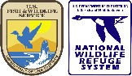
North Dakota Wetland Management Districts

104°0'0"W
49°0'0"N

103°0'0"W

102°0'0"W

101°0'0"W

100°0'0"W

99°0'0"W

98°0'0"W

97°0'0"W
49°0'0"N

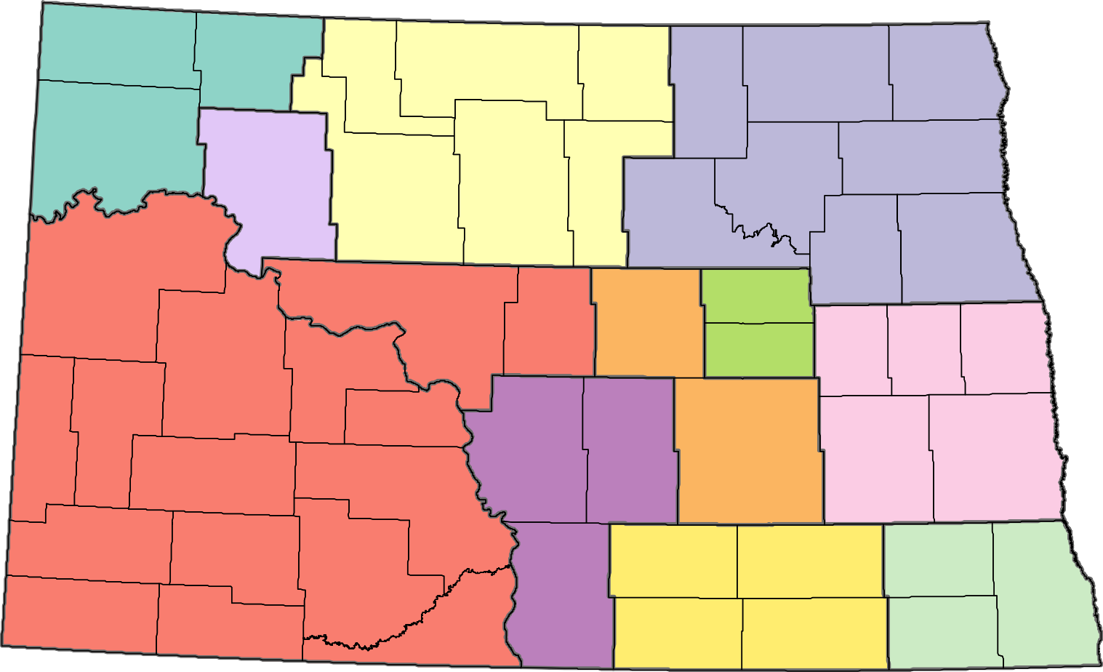
·
DIVIDE
BURKE
RENVILLE
BOTTINEAU
ROLETTE
CAVALIER
PEMBINA
CROSBY-LOSTWOOD WMD
WILLIAMS
TOWNER
J CLARK SALYER WMD
DEVILS LAKE WMD
WALSH
MOUNTRAIL
PIERCE
WARD
MC HENRY
RAMSEY
BENSON
MC KENZIE
NELSON
GRAND FORKS
EDDY
MC LEAN
SHERIDAN
ARROWWOOD
WELLS WMD
DUNN
FOSTER
GRIGGS
STEELE
TRAILL
MERCER
GOLDEN VALLEY
BILLINGS
AUDUBON WMD
OLIVER
BURLEIGH
KIDDER
CHASE LAKE WMD
STUTSMAN
VALLEY CITY WMD
BARNES
CASS
STARK
LONG LAKE WMD
MORTON
SLOPE
HETTINGER
LOGAN
LA MOURE
GRANT
EMMONS
BOWMAN
RANSOM
TEWAUKON WMD
ADAMS
KULM WMD
SIOUX
MC INTOSH
DICKEY
SARGENT
RICHLAND
0
15
30
60
90
120
Miles

104°0'0"W
Complexes

Northwest ND

Eastern ND
Central ND
Lostwood WM D Kory Richardson 8315 Highway 8
Kenmare, ND 58746
701-385-4046
Crosby WMD Scott Williams
10100 Hw y 42 NW
Crosby, ND 58730
701-965-6488
Scott_A_Williams@ fws.gov
J Clark Salyer WMD John Takala
681 Salyer Road Upham, ND 58789 701-768-2548
john_takala@fws.gov
Northwest ND WMD Complex
Kyle Flanery 681 Salyer Road
Upham, ND 58789
701-768-2548
kyle_flanery@ fws.gov
46°0'0"N
46°0'0"N
103°0'0"W
102°0'0"W
101°0'0"W
100°0'0"W
99°0'0"W
98°0'0"W
97°0'0"W

Kulm WMD
Wayne Henderson 1st St. SW P.O.Box E
Kulm, N D 58456 701-647-2866
47°0'0"N
48°0'0"N
47°0'0"N
48°0'0"N

Tewaukon WMD
Noah Hazard
9754 143 ½ Ave SE Cayuga, ND 58013 701-724-3598
noah_hazard@fws.gov

Audubon WMD Kathy B aer
3275 11th Street NW Coleharbor, ND 58531 701-442-5474
kathy_baer@fws.gov
Central ND WMD Complex Todd Luke
3275 11th Street NW Coleharbor, ND 58531
701-442-5474

Long Lake WMD Jared New ton 12000 353rd St SE
Moffit, ND 58560
701-387-4397
Jared_newton@ fws.gov
Chase L ake WM D Jak e Hourt
5924 19th St SE
Woodworth, ND 58496 701-752-4218
Eastern ND WMD Complex
Dave Azure
7780 10th St. SE
Pingree, ND 58476
701-285-3341
dave_azure@fws.gov
Arrow wood WMD Stacy Whipp
7780 10th St. SE
Pingree, ND 58476 701-285-3341
stacy_whipp@fws.gov

Devils Lake WMD Brian Vose
221 2nd St. NW, Suite 2
Devils Lake, ND 58301
701-662-8611
bian_vose@fws.gov
Valley City WM D Kurt Tompkins 11515 River Rd
Valley City, ND 58072
701-845-3466
kurt_tompkins@ fws.gov

Data Sources: BLM: County Boundaries, USFWS: WMD Boundaries, Complex Boundaries. Map Date: 6/15/2021, HAPET 2/8/2023

