DRAFT STORMWATER HYDRAULICS REPORT | Project No. PCN  XX-0-000(000)000 12345  From point A to point B    XX  Prepared by  NORTH DAKOTA DEPARTMENT OF TRANSPORTATION  BISMARCK, NORTH DAKOTA  http://www.dot.nd.gov/  DIRECTOR  Ronald J. Henke, P.E.  PROJECT DEVELOPMENT DIRECTOR  Jon Ketterling, P.E.  Principal Author: (Consulting Firm OR name, NDDOT Division name)  MONTH, YEAR
23 USC § 407
NDDOT Reserves All Objections

PROJECT NAME

PROJECT LOCATION

CERTIFICATION


Contents
1 Introduction 1
1.1 Project Summary 1
2 Background 2
2.1 Project Location 2
2.2 Project Construction History 2
2.3 Existing Conditions 3
3 Design Criteria & Approach 4
3.1 Methodology 4
3.2 Minimum Flood Frequency 4
3.3 Floodplain/Floodway 5
3.4 Hydrology 5
3.5 Assumptions 5
4 Results 6
4.1 Existing Conditions Modeling 6
4.2 Proposed Conditions Modeling 6
4.3 Summary of Recommendations 7
5 City Cost Participation Summary 8

Appendices
Appendix A: Site Layout
Appendix B: Drainage Area Maps
Appendix C: Existing Conditions Results
Appendix D: Proposed Conditions Results
Appendix E: City Cost Participation
Appendix F: FEMA FIRM Maps

Introduction
This report documents the hydraulic analysis of storm drainage improvements along (highway name, vicinity, description). Information about the (study area, methodology, existing/proposed condition modeling results, etc) will be discussed.

Project Summary
Project XX-0-000(000)000 is currently scheduled for a MM/DD/YY plan completion date, and is anticipated to be constructed during the YYYY construction season(s). The proposed project includes (provide a summary of the scope of work of the proposed project.
Note any proposed improvements to existing pavement, lighting, signals, pedestrian/bike facilities, water main, storm sewer, lift stations, and sanitary sewer. Describe any major changes in drainage patterns from existing and proposed conditions).

Background

Project Location
The proposed project is located in City, North Dakota along Highway ##, as shown in Figure 1. The section of Highway ## being evaluated is classified as a (insert Functional Classification).
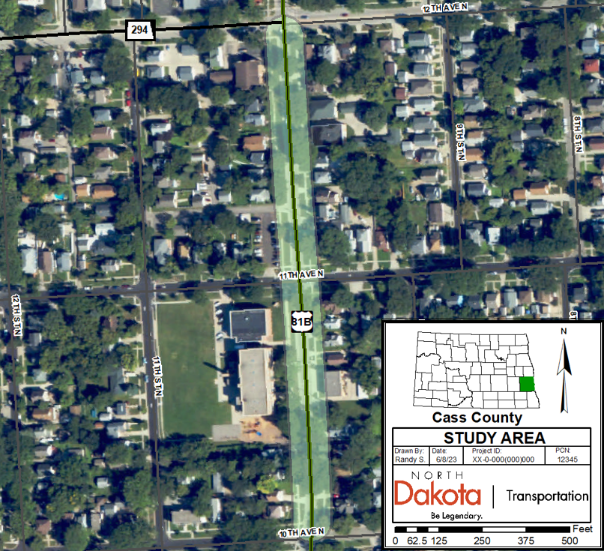
Figure 1: Project Location Map

Project Construction History
Provide a history of the existing drainage system, including dates the system was installed and any major modifications to the system since the date of initial construction.

Existing Conditions
Provide a summary of the condition of the existing roadway and storm system. Make note of any history of flood concerns with the existing system and the existing system’s design flood frequency event, if known.

Design Criteria & Approach

Methodology
Describe the modeling used for the analysis and any software utilized. Describe any design standards (NDDOT Design Manual, ND Administrative Code 89-14, HEC-22, etc) used for the analysis. Note the allowable design spread used for inlet design calculations (Chapter V-03.02.04 of the NDDOT Design Manual). Describe discharge methods utilized (i.e. Rational Method/SCS Runoff Method/Other) and the sources of any data collected for the model such as ground survey, topographic maps, LiDAR, on-site inspections, soils information, and rainfall data used for the analysis (typically NOAA Atlas 14). Indicate vertical datum used (i.e. NGVD 29/NAVD 88) used for elevations provided in the analysis.

Minimum Flood Frequency
As per Article 89-14 of the North Dakota Administration Code (ND Stream Crossing Standards), based on the functional classification of (insert classification) for Highway ##, a ##-year minimum design flood frequency was used for this analysis. (If portions of the storm drain system are located at an underpass, make note of what design event was used for the sections of the system contributing flow to the underpass, which typically has a higher minimum design flood frequency). The minimum design flood frequency requirements as stated by ND Administrative Code 89-14 are shown below in Figure 2.
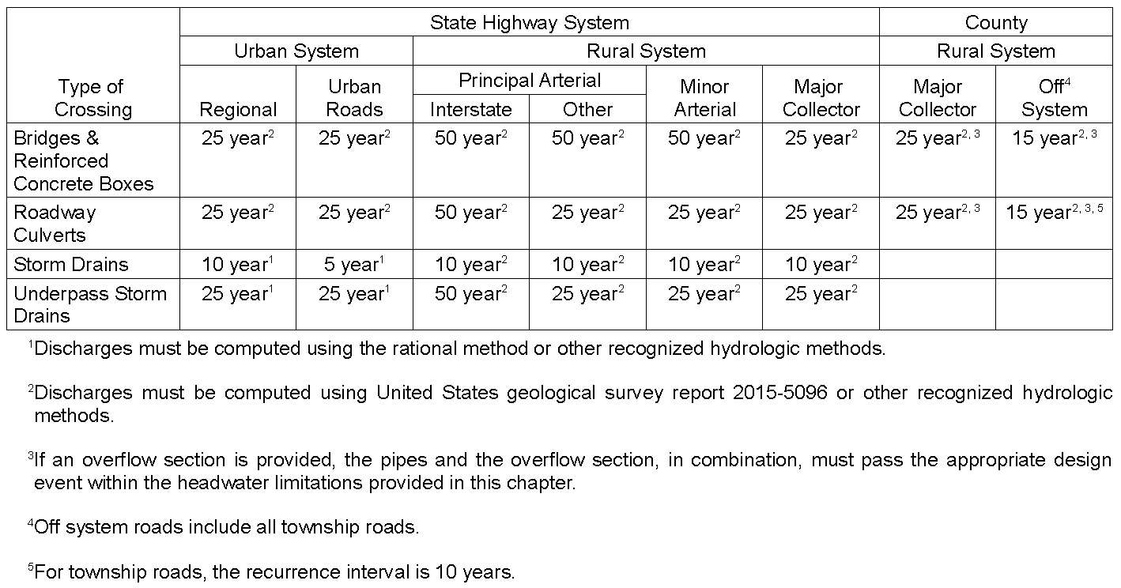
Figure 2: Minimum Design Flood Frequency

Floodplain/Floodway/Permitting
Note whether the project is located within a floodplain/floodway or discharges into one. If applicable, include a figure of the FIRM map in the appendices. Document any necessary permits or environmental requirements such as floodway authorization, floodplain, sovereign lands, 404 permits, etc.

Hydrology
Drainage areas were mapped using (digital terrain models, on-site topographic survey, topographic maps, LiDAR data, on-site inspections, etc). The mapped areas are shown in the appendices and have been labeled with the corresponding Times of Concentration, Runoff C/Curve Number values, and drainage structures that the areas drain towards.

Assumptions
In accordance with Chapter V of the NDDOT Design Manual, the following design approach and assumptions were used for analysis of the proposed storm system: (Note – assumptions provided below are for an example project. Add, modify, or delete assumptions applicable to the relevant project below and in accordance with NDDOT Design Manual.)
- A runoff coefficient of 0.90 was assumed for pavement land use areas.
- For inlet design, a minimum time of concentration of 5 minutes was assumed for basins with impervious surfaces, and 10 minutes for pervious surfaces.
- For trunk line design, a minimum time of concentration of 10 minutes was assumed for basins with impervious surfaces, and 15 minutes for pervious surfaces.
- A Manning’s n value of 0.012 was assumed for smooth-walled storm drain pipe.
- The velocity of flow in the storm drain should not be less than 3 ft/sec.
- Storm drain pipes should generally not exceed 80% full by depth.
- A minimum diameter of 15 inches was assumed for proposed storm drain pipe.
- Manhole spacing should generally be limited to a maximum of 400 feet.
- Manholes were sized as per guidance in V-03.03.06 of the NDDOT Design Manual.
- For multi-lane roads (excluding at underpasses), an allowable spread width of 7.5 feet (shoulder width plus one-half driving lane) was used where longitudinal grades exceeded 1.0%. For longitudinal grades of 1.0% or flatter, an allowable spread width of 13.5 feet (shoulder width plus full driving lane) was used.
- For multi-lane roads through an underpass, an allowable spread was utilized to provide one drivable lane in each direction, which is equal to an allowable spread width of 25.5 feet for this project.

Results

Existing Conditions Modeling
Note: Typically, Existing Conditions Modeling may be omitted from analysis if the storm system does not increase discharges into an existing downstream storm system and is not located within a FEMA Flood Zone. In such instances, contact NDDOT Bridge Division to determine whether Existing Conditions Modeling is warranted, and provide a brief justification here if Existing Conditions Modeling was omitted from the analysis. If Existing Conditions Modeling is warranted, provide a summary of the results as described in the paragraph below.
Describe in detail the model results for the existing conditions. Discuss roadway profile and allowable spread for inlets on current system. Include typical sections of existing roadway sections. Indicate the assumed outfall conditions used for the model (i.e., was a free outfall or constant tailwater used, or does the system drain into an existing storm system). Make mention of any areas exceeding current design standards (including inlet spread requirements and storm pipes at pressure flow or surcharging out of inlets/manholes). Include HGL profile of existing storm trunk line, if available. Include existing drainage area maps and summary tables of the drainage areas, inlets, and storm drain pipes in the appendices. Add summary of existing lift station hydraulics, if applicable.
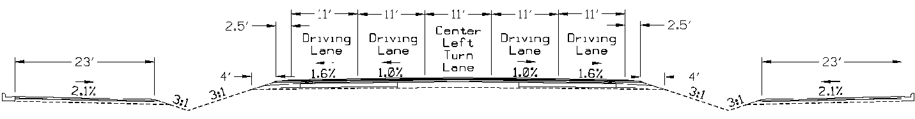
Figure 3: Existing Typical Section

Proposed Conditions Modeling
Describe in detail the model results for the proposed conditions. Discuss roadway profile and allowable spread for inlets on proposed system. Include typical sections of proposed roadway sections. Indicate the assumed outfall conditions used for the model (i.e., was a free outfall or constant tailwater used, or does the system drain into an existing storm system). Note any storm drain pipes at pressure flow or surcharging out of drainage structures and provide an explanation. Include HGL profile of proposed storm trunk line. Include proposed drainage area maps and summary tables of the drainage areas, inlets, and storm drain pipes in the appendices. Add summary of proposed lift station hydraulics, if applicable. Summarize what impact, if any, that the project will have on storm systems downstream of the project section.
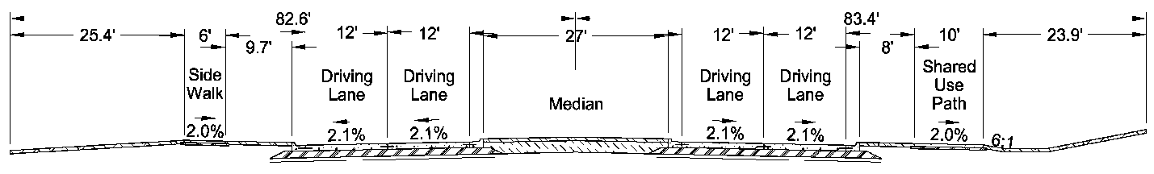
Figure 4: Proposed Typical Section

Summary of Recommendations
Provide a brief summary of the existing storm system and the impact the proposed changes will have on the corridor and downstream of the corridor.

City Cost Participation Summary
Appendix V-03D of the NDDOT Design Manual states that the Department and cities share drainage costs for storm drain trunk lines on a percentage basis in proportion to their contributions to the total flow rate for any contributing areas outside of the project corridor. The general guidance defines the project corridor as the area that lies within one city block on either side of the highway, or where city blocks don’t exist, up to a distance of 450 feet from centerline of the project highway/street. (Note that the computed project corridor flow rates should include all contributing discharges within the one city block (or 450 feet) region along the specified highway that contribute drainage towards the trunkline, regardless of longitudinal proximity to the begin/end limits for the given project. Refer to example layout map in the Appendices for further information.)
Determine whether offsite drainage areas increase the total flow rate intercepted by the trunk line, then choose/modify the appropriate paragraph below to indicate whether additional city cost participation is required on this project.
Based on a preliminary analysis of the contributing drainage areas at this site, all the contributing drainage appears to be within one city block of the project corridor. Therefore, additional city participation for trunk line costs is not anticipated for this project.
OR
To determine the proportion of flows resulting from adjacent city drainage, two proposed conditions models were created. One model contained just the project corridor flow rates, while the other model included flow rates from the combined project corridor and adjacent city areas. A summary table of the City Cost Participation is shown in Appendix E.

Appendix A: Site Layout
Include a layout of the existing and proposed storm systems (including Section 55 preliminary plan sheets if prepared), with storm sewer structures properly labeled as per guidance given in V-03.01.03 of the NDDOT Design Manual:
Manholes in a storm drain system should be labeled numerically in the plans, with manhole numbers increasing in the direction of increasing plan stationing. Inlets should be labeled with the number of the associated manhole that they drain to, along with an alpha designation. As an example, the first inlet at the beginning of a project might be Inlet 1A. If an Inlet-Special (as shown on Standard Drawing D-722-1B) will be installed and will function also as a manhole for the trunk line, then it should be labeled with a sequential number and alpha (typically “A”). For example, the third manhole in a trunk line, if it is an Inlet-Special, would be labeled “3A”.

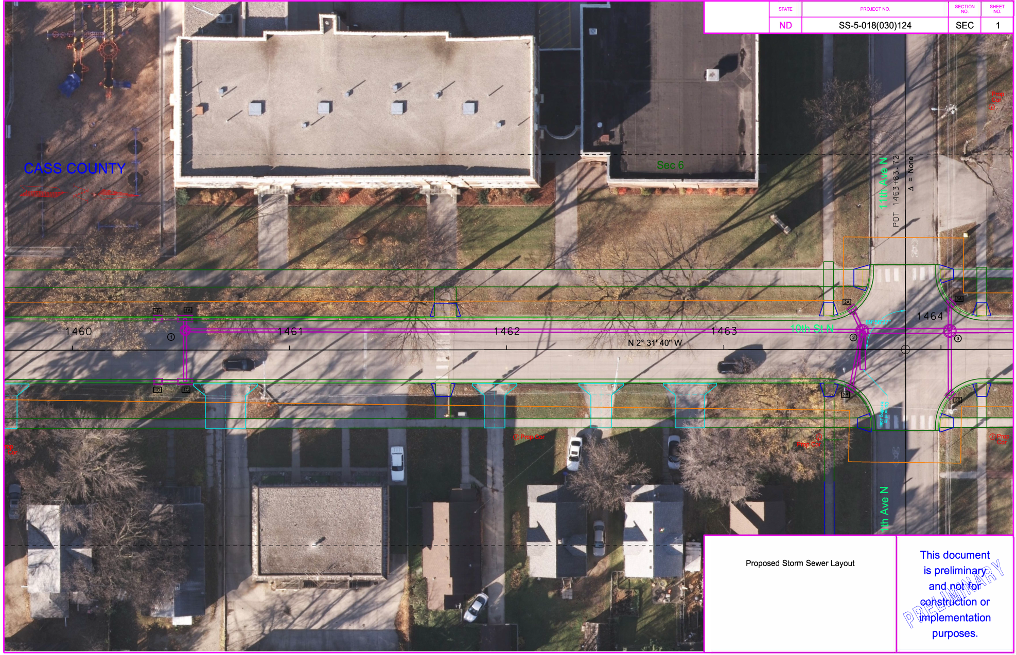

Appendix B: Drainage Area Maps
Include maps of the drainage areas. Ensure drainage areas are labeled to match the corresponding inlets that they drain to (i.e., the area draining towards Inlet “1A” should be labeled as drainage area “1A”, etc).

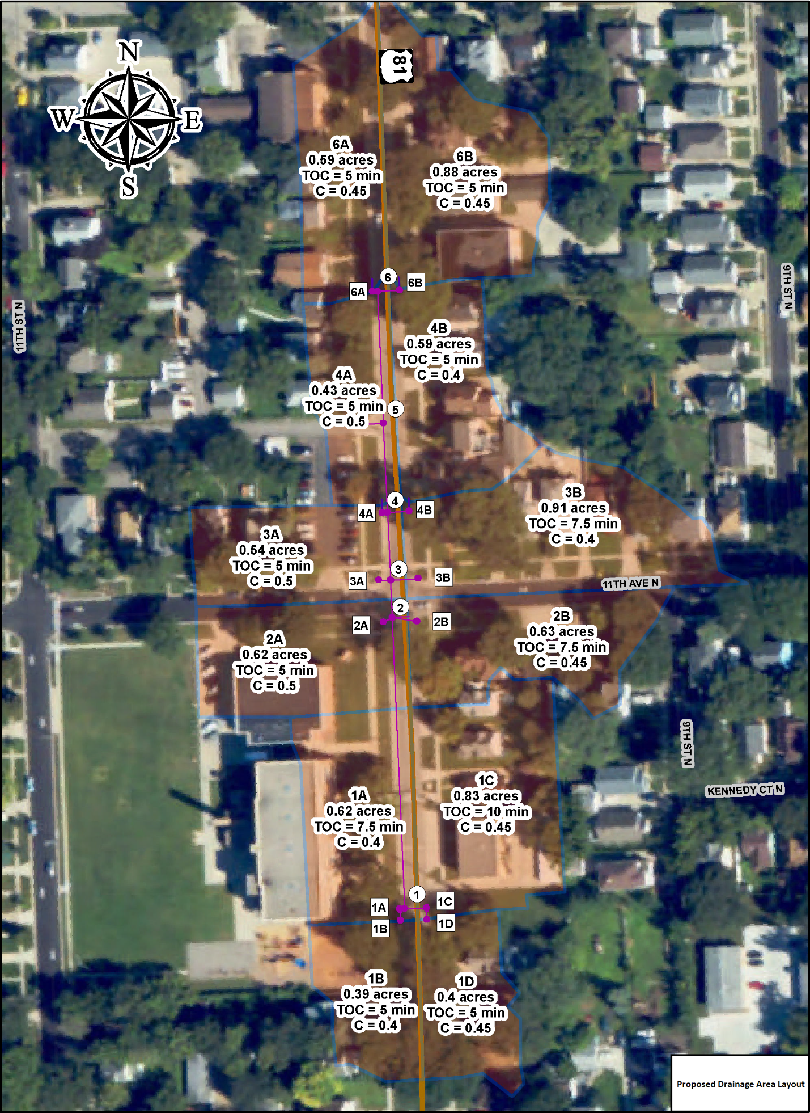

Appendix C: Existing Conditions Results
Note: if no Existing Conditions Modeling was performed, this appendix may be omitted.
Include completed Existing Drainage Area, Inlet, and Storm Drain Pipe Summary Tables (as provided in Urban Storm Drainage Calculations Spreadsheet on NDDOT References and Forms page). Additional printouts from modeling such as HGL profiles, hydrographs, and lift station calculations may be included here as well.

Appendix D: Proposed Conditions Results
Include completed Proposed Drainage Area, Inlet, and Storm Drain Pipe Summary Tables (as provided in Urban Storm Drainage Calculations Spreadsheet on NDDOT References and Forms page). Additional printouts from modeling such as HGL profiles, hydrographs, and lift station calculations may be included here as well.

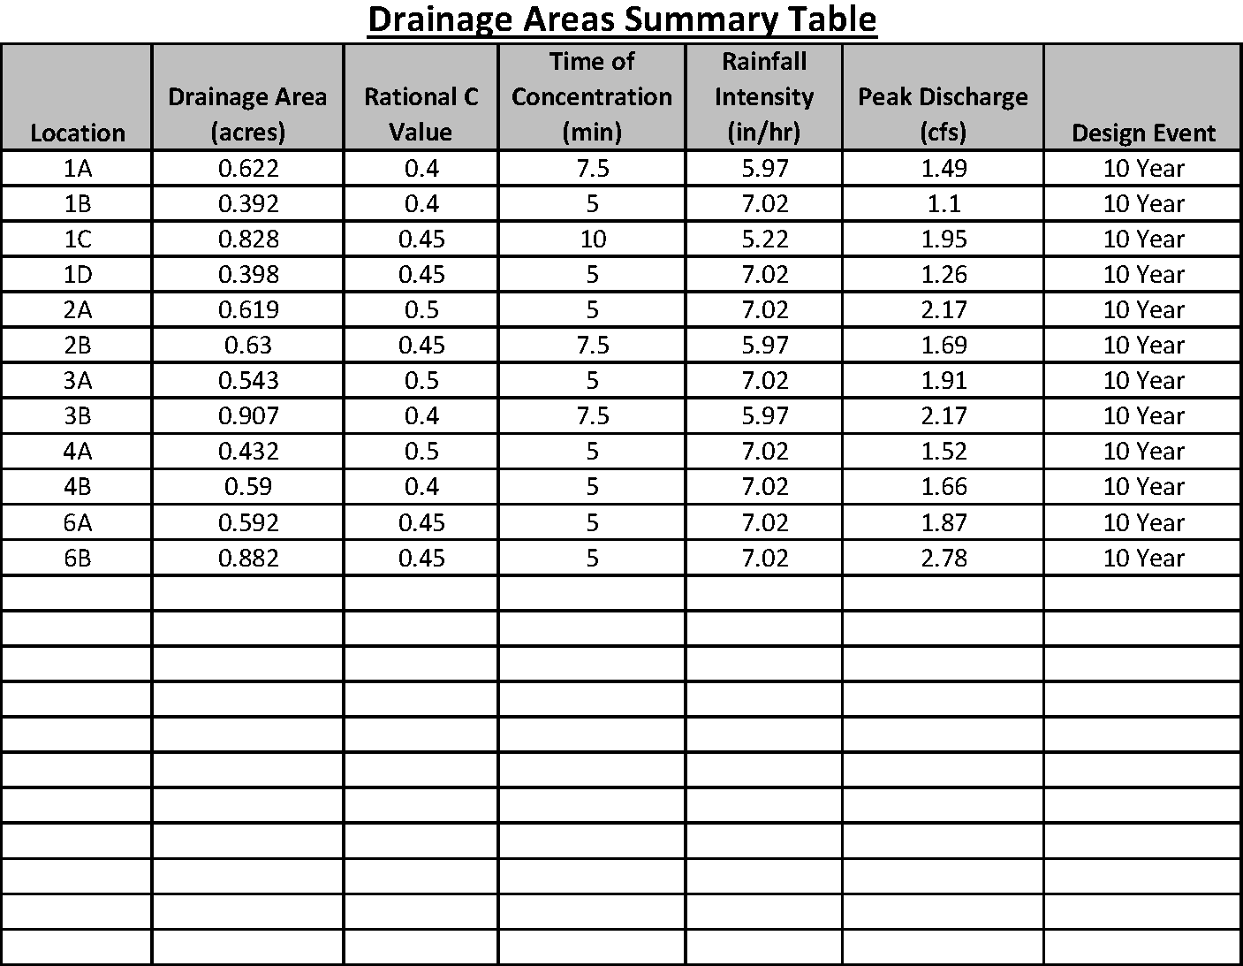
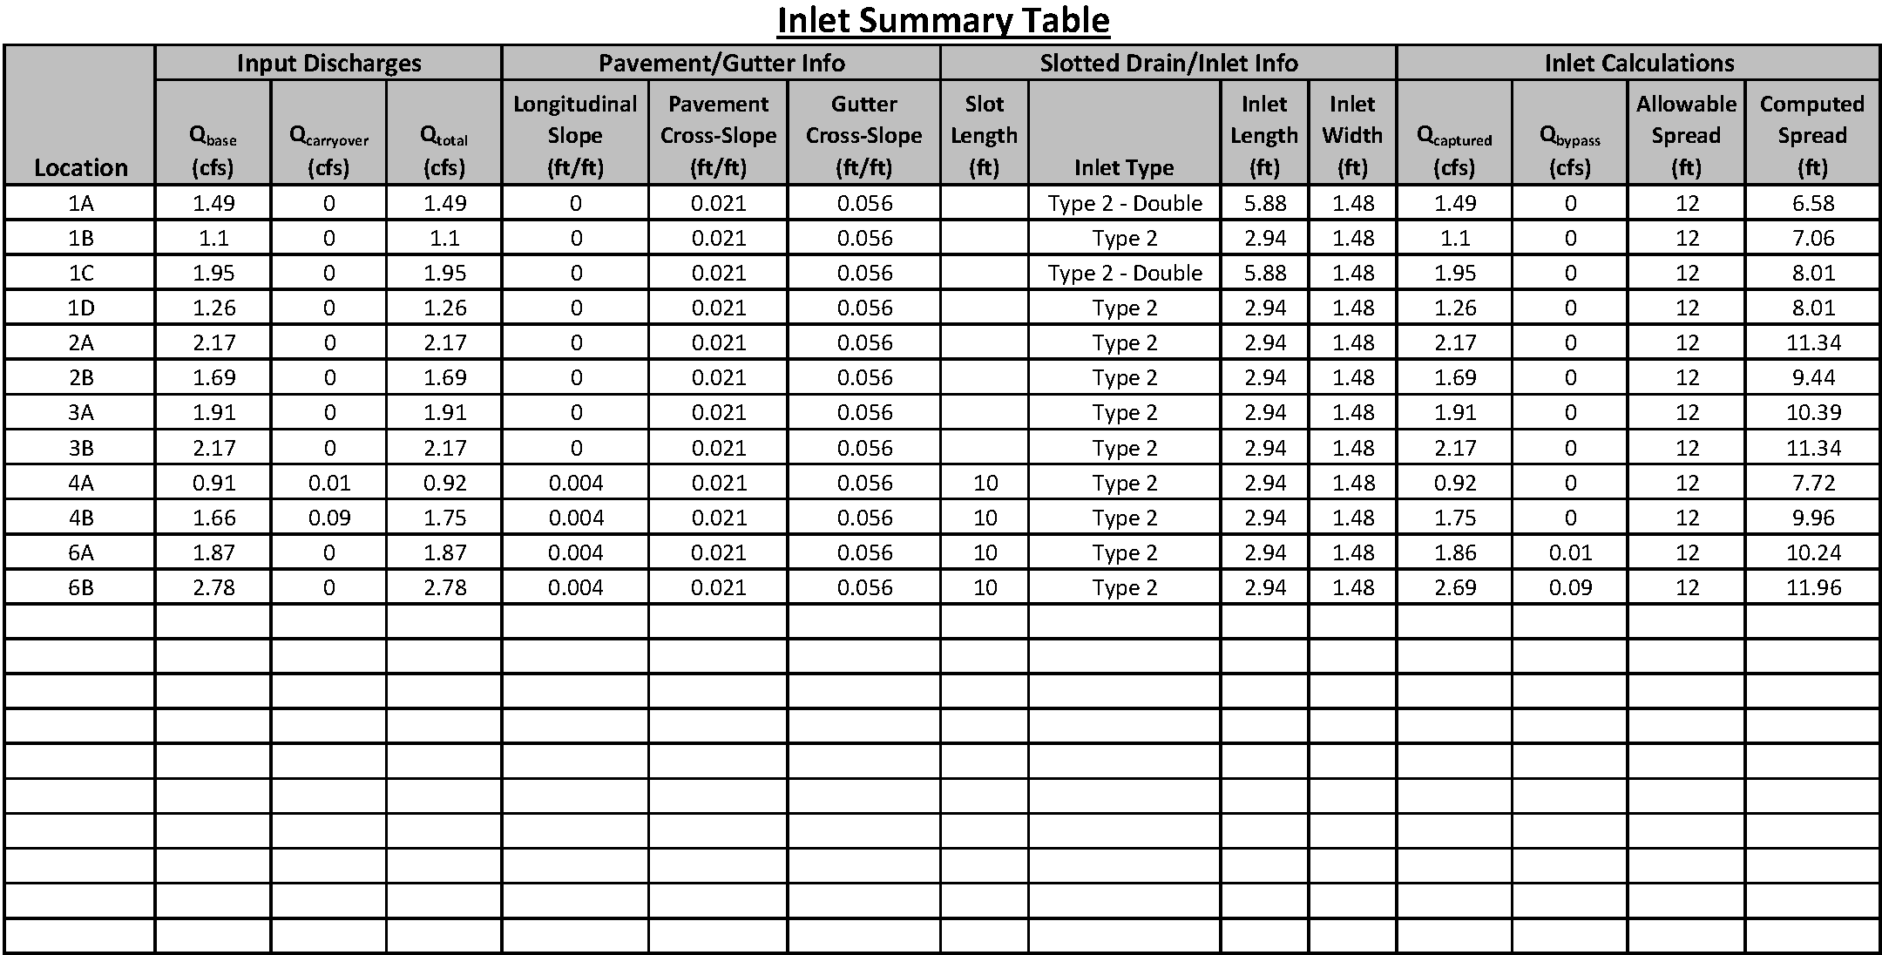
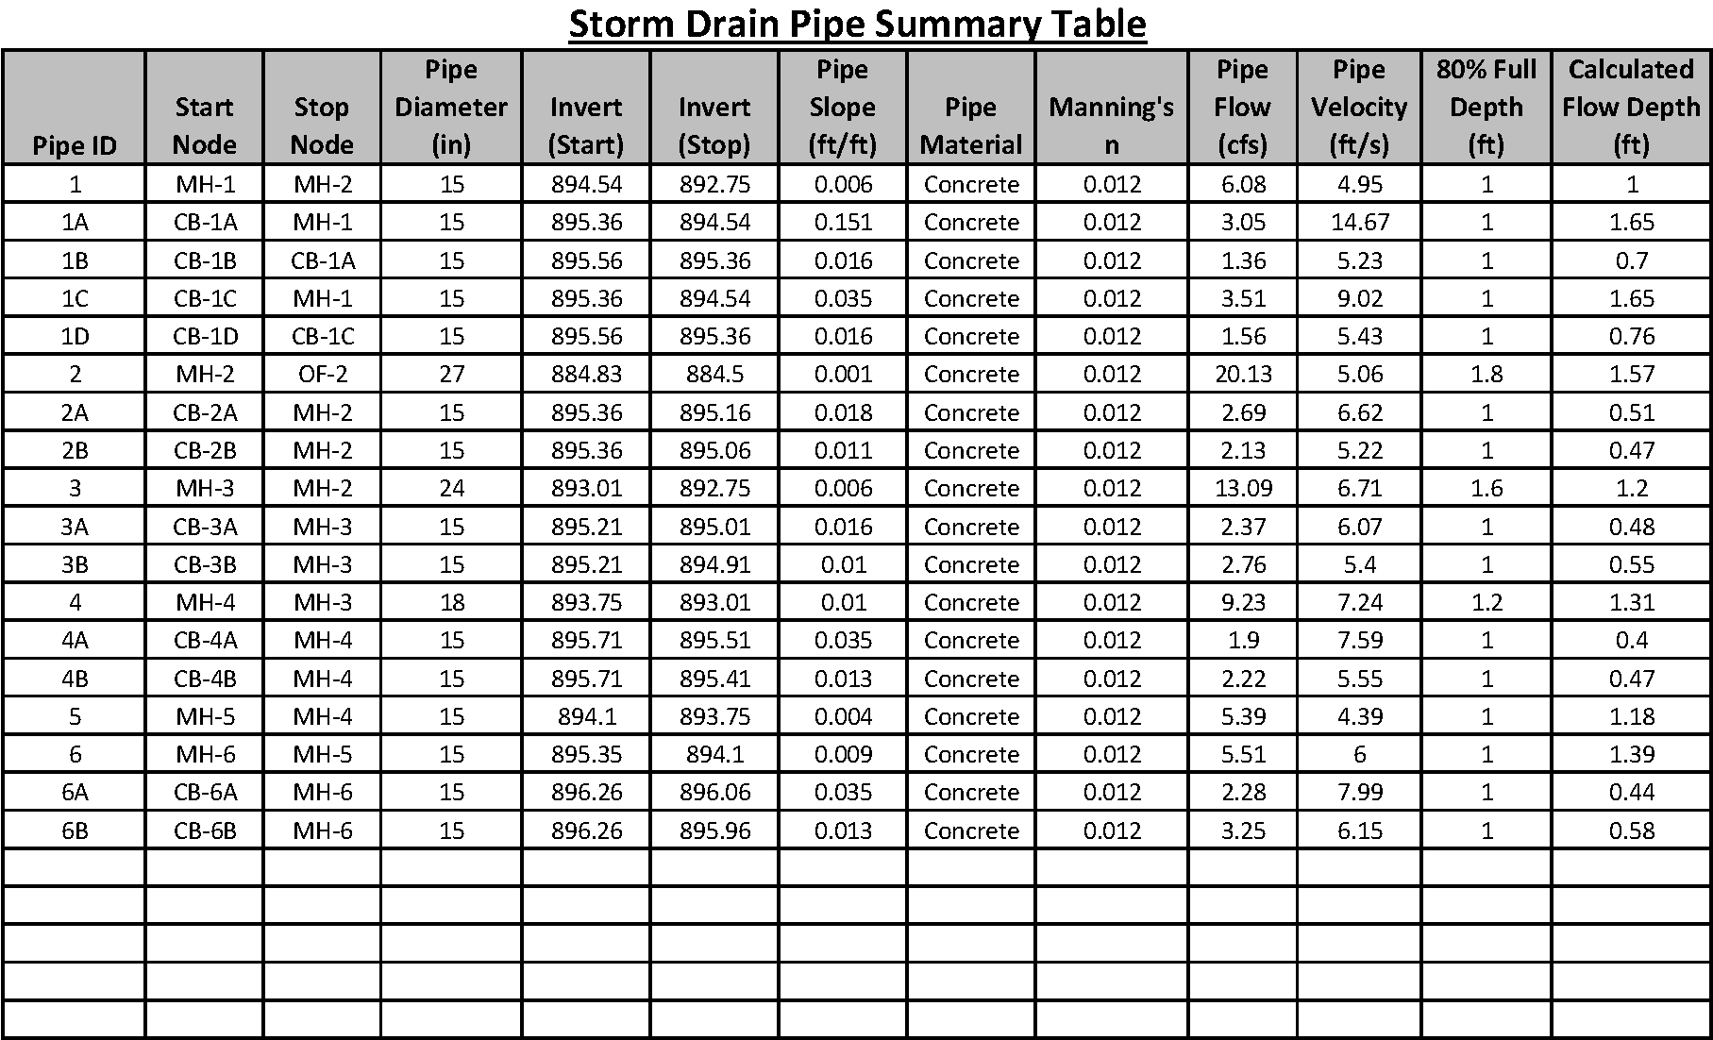

Appendix E: City Cost Participation
Include completed City Cost Participation Layout Map & City Cost Participation Summary (if applicable) as provided in Urban Storm Drainage Calculations Spreadsheet.

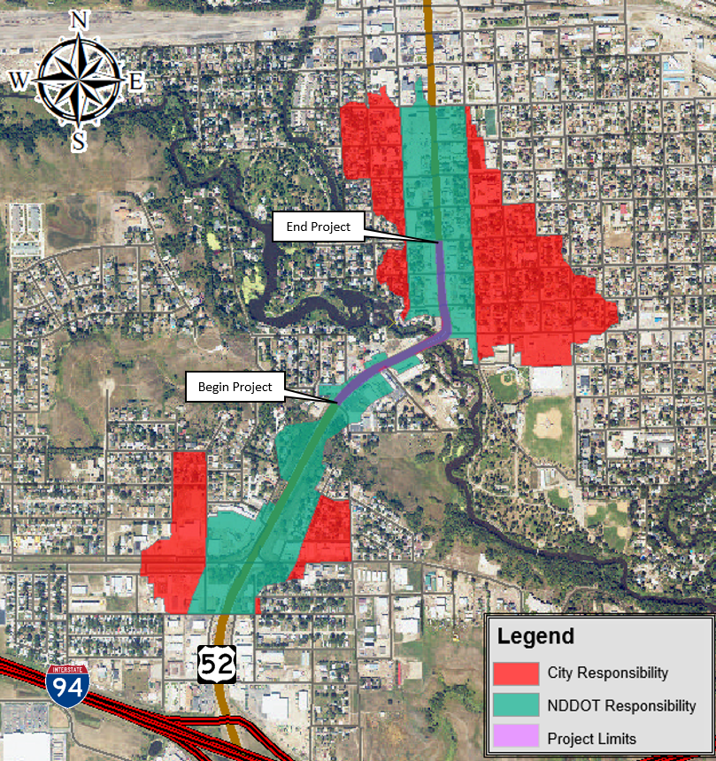.
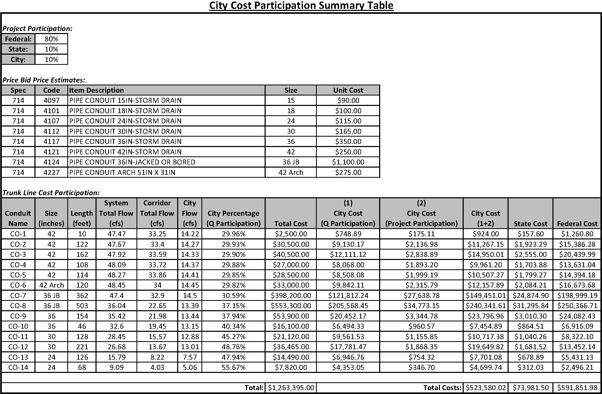

Appendix F: FEMA FIRM Maps
If the project is located within or discharges into a floodplain/floodway, include FEMA FIRM Maps here.
