DRAFT ROADWAY HYDRAULICS REPORT | Project No. PCN  XX-0-000(000)000 12345  From point A to point B    XX  Prepared by  NORTH DAKOTA DEPARTMENT OF TRANSPORTATION  BISMARCK, NORTH DAKOTA  http://www.dot.nd.gov/  DIRECTOR  Ronald J. Henke, P.E.  PROJECT DEVELOPMENT DIRECTOR  Jon Ketterling, P.E.  Principal Author: (Consulting Firm OR name, NDDOT Division name)  MONTH, YEAR
23 USC § 407
NDDOT Reserves All Objections

PROJECT NAME

PROJECT LOCATION

CERTIFICATION


Contents
1 Introduction 1
2 Background 3
2.1 Project Location 3
2.2 Project Construction History 3
2.3 Existing Conditions 3
3 Design Criteria & Approach 4
3.1 Methodology 4
3.2 Minimum Flood Frequency 4
3.3 Hydrology 5
3.4 Assumptions 5
3.5 Energy Dissipation 5
4 Results 6
4.1 Modeling 6

Appendices
Appendix A: HY8 Culvert Analysis Reports (If more than 10 stream crossings separate from document)
Appendix B: Drainage Areas
Appendix C: Preliminary Hydraulic Data
Appendix D: StreamStats (If applicable or accurate)

Introduction
This report documents the roadway hydraulic analysis along (highway name, vicinity, description). The author of this report certifies that the recommendations provided herein are made in accordance with the requirements of Article 89-14 of the North Dakota Administration Code (ND Stream Crossing Standards) and the NDDOT Design Manual.
Project XX-0-000(000)000 has a project completion date of MM/DD/YY and is anticipated to be constructed during the YYYY construction season(s). The proposed project includes providing a summary of the scope of work of the proposed project. Note PS&E date, or date it was held if known.
The proposed project includes replacement of [#] pipes/structures, and extensions of [#] pipes/structures.
Only pipe/structure replacements were analyzed for conveyance. Pipe/structure extensions were not analyzed for conveyance. A summary of the pipes/structures analyzed for replacement is provided below:
- Approach pipes
  - This project is expected to include replacement of # approach pipes, while another # approach pipes are anticipated to be extended.
  - The minimum diameter for new approach culverts up to 75 feet in length is 18 inches. New approach culverts longer than 75 feet will have a minimum diameter of 24 inches.
- Centerline Pipes
  - Existing centerline pipes were all analyzed for stream crossing standard compliance.
  - The minimum diameter of new centerline pipe culverts shall be 24 in. The maximum length of this diameter culvert shall be 100 feet (measured by pay length, from opening of end section to opening of end section at the crown of the pipe) for new installations. If more length is needed, a 30 in. diameter culvert should be used. Existing culverts smaller than 30” in diameter may be extended to lengths greater than 100 feet.
- Structural Plate Pipe
  - The bridge preliminary concept report and/or scoping report recommended improvements for the existing structural plate pipe(s) that have an associated Bridge Listing #. Structural plate pipes that did not have a Bridge Listing # were treated as centerline pipes above.
- Box Culverts
  - The bridge preliminary concept report and/or scoping report recommended proposed improvements.
- Cattle Pass (See Section 2.24 of the Right of Way Manual)
  - The bridge preliminary concept report and/or scoping report recommended proposed improvements. The existing cattle pass structure is/is not being used for drainage.
This project strategy is a (Investment Strategy). Provide a general description of what will happen to the stream crossings.

Background

Project Location
The proposed project is located along Highway ##, from RP 00.00 to RP 00.00, as shown in Figure 1. This section of Highway ## being evaluated is classified as a (insert Functional Classification) as per the NDDOT Functional Classification System.



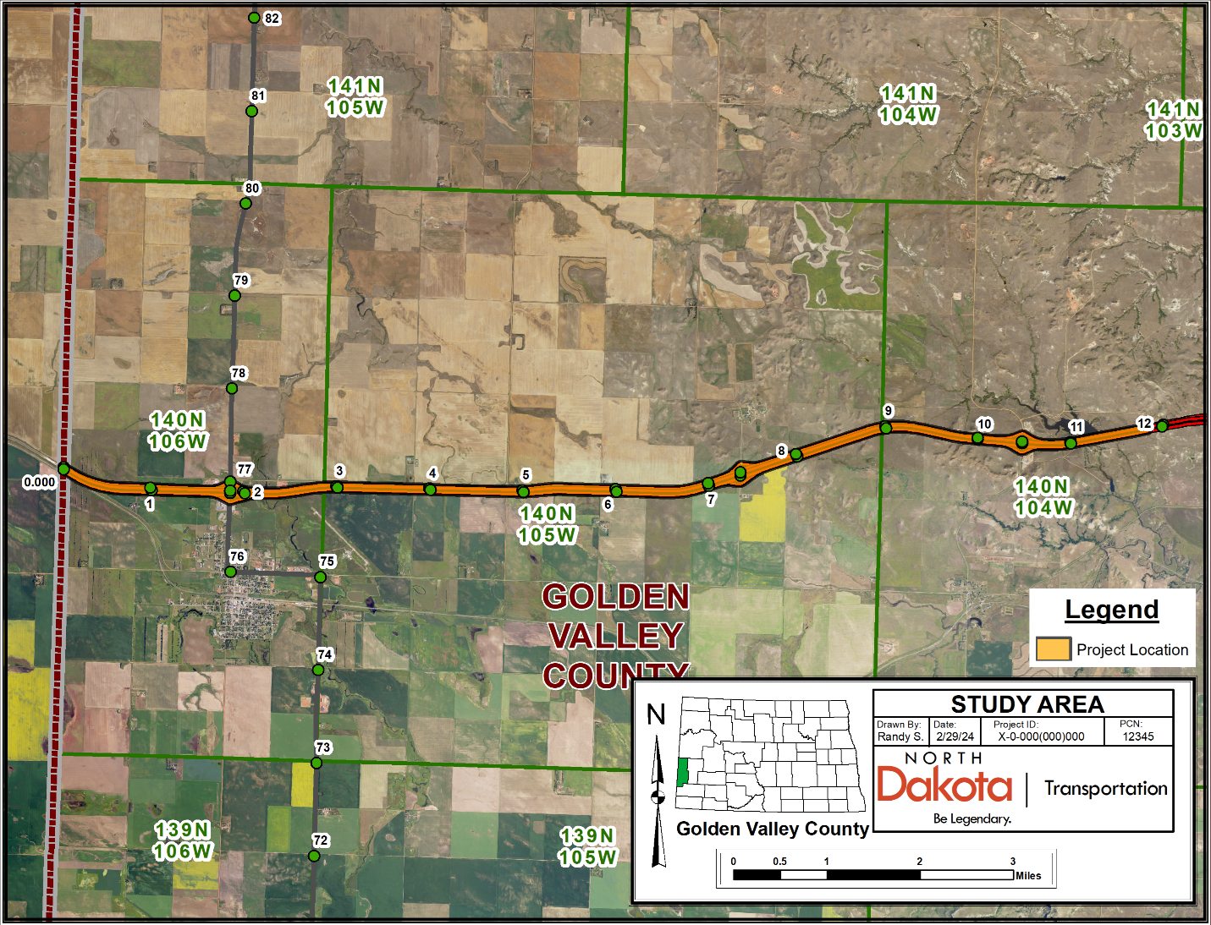
Example Map Shown. Map should contain:
- Township, Range
- North Arrow
- County
- Labeled Highways with Reference Points (or stationing if applicable)
- Depict the project site’s beginning and end (project limits)
Beach
16
94
Figure 1: Project Location Map

Project Construction History
Provide a brief history of the original grading plans (stream crossings vs corridor drainage systems), including the date(s) the stream crossings were installed (if known, consider date of grading plans). Also add any major modifications to the system since the date of initial construction (if known).

Existing Conditions
Provide a summary of the stream crossings that were analyzed. Make note of any history of known flood concerns within the existing study area, if known.

Design Criteria & Approach

Methodology
These culverts lie within USGS Hydrologic Zone X for North Dakota. In accordance with the NDDOT Design Manual Section (i.e. V-01.04), the Regression Equations from the United States Geological Survey (USGS) report, “Scientific Investigations Report 2015-5096: Regional Regression Equations to Estimate Peak-Flow Frequency at Sites in North Dakota Using Data through 2009”, were used to calculate the peak flows. This technique uses regression equations developed from stream gaging stations to determine the peak runoff for a specified runoff event. The contributing drainage areas were manually delineated for each crossing using (ArcGIS/GIS software, topographic maps, LiDAR data, etc) with StreamStats used solely as a reference (delete as applicable). The stream lengths were determined from (longest flow paths, NHD flowlines, etc). Drainage area maps for these crossings can be found in the Appendix.

Minimum Flood Frequency
The minimum design flood frequency requirements as stated by ND Administrative Code 89-14 are shown below in Figure 2. Based on the functional classification of (insert classification) for Highway ##, a XX-year recurrence interval was used for the design flood frequency event for the hydraulic analysis of centerline culverts. For approach crossings, a XX-year recurrence interval was used for the design event for the hydraulic analysis of approach culverts.
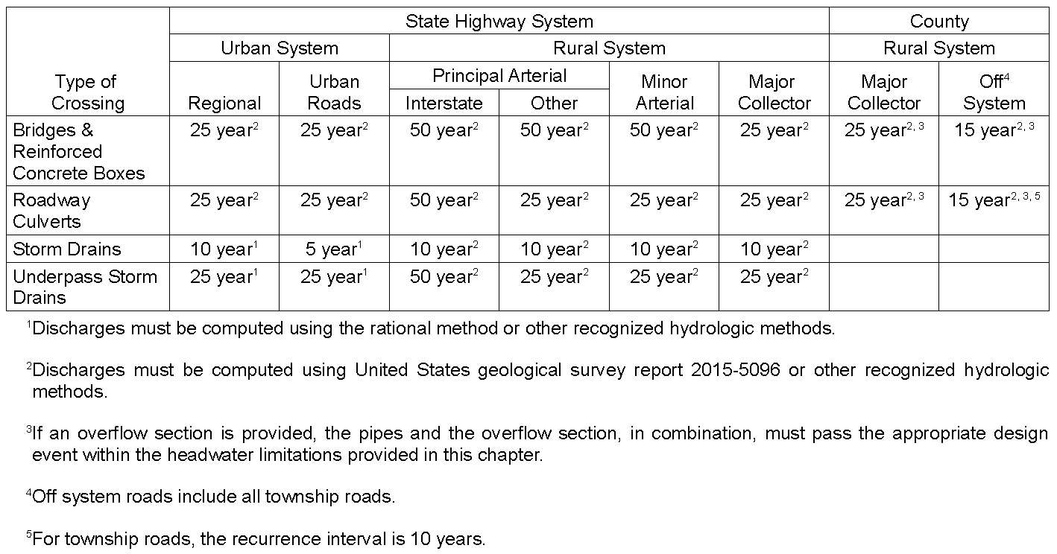
Figure 2: Minimum Design Flood Frequency

Hydrology
Drainage areas were mapped using (digital terrain models, on-site topographic survey, LiDAR, topographic maps, on-site inspections, etc). The mapped areas are shown in the appendices and have been labeled with the corresponding culvert crossings that the areas drain towards.

Assumptions
In accordance with Chapter V of the NDDOT Design Manual, the following design approach and assumptions were used for analysis of the proposed drainage system: (Note – assumptions provided below are for an example project. Add, modify, or delete assumptions applicable to the relevant project below and in accordance with NDDOT Design Manual.).
- A Manning’s n value of 0.012 was assumed for smooth-walled pipe.
- A minimum diameter of 24 inches was assumed for new centerline pipes. New centerline pipes longer than 100 feet were assumed to have a minimum diameter of 30 inches.
- A minimum diameter of 18 inches was assumed for approach pipes. Approach pipes longer than 75 feet were assumed to have a minimum diameter of 24 inches.
- New approach pipes were evaluated with a Manning’s n value of 0.024 for corrugated pipes. For approach pipes with a diameter of 24” or smaller, the corrugated pipe size was determined, and the smooth-walled alternative was specified in the same (either 18” or 24”) diameter. For corrugated pipes with a diameter of 30” or larger, the smooth-walled alternative was modeled separately, with a smooth-walled alternative size being chosen which provided a headwater sufficiently equivalent to that of the corrugated alternative (up to 2% higher than the headwater provided by the corrugated alternative).

Energy Dissipation
Where practical, all culverts were sized such that the discharge velocity does not exceed 10 feet per second (in areas where very poor soils are prevalent, such as the badlands, reducing the velocity threshold to 7 feet per second or higher may be warranted). In cases where culverts exhibited high velocities that couldn’t be addressed simply by increasing the culvert size, the evaluation of broken-back culverts was undertaken to determine if this approach could bring down the outlet velocity within an acceptable range. Where sizing and culvert slope adjustments could not practically limit the discharge velocity to 10 feet per second (or 7 feet per second for badlands soils), an assessment of erosion control measures such as riprap was conducted at the culvert outlet.
Refer to Section V-04.07 of the NDDOT Design Manual for guidance on Energy Dissipation and V-04.08 for guidance on Broken-Back Culverts.

Results

Modeling
As per Section V-04.06 of the NDDOT Design Manual, the pipe culverts were modeled using FHWA’s HY-8 Culvert Hydraulic Analysis Program, Version #.#, to determine the proper culvert sizes required. Refer to Appendix A for the HY-8 Culvert Analysis Reports (if greater than 10 stream crossings evaluated, the culvert analysis reports should be excluded from the report’s appendices and provided as a separate deliverable).
Provide a summary of the results, noting any unique circumstances. Specify the total number of centerline culverts and approach culverts recommended for replacement. When applicable, include recommendations for erosion control measures or riprap aprons at culvert outlets. Include tables showing hydraulic calculations similar to the examples provided below.
 | CENTERLINE CULVERT HYDRAULIC DATA FOR XX-0-000(000)000 (A)
 |  |  |  |  |  |  | 25/50 -YEAR DATA |  |  |  | 100-YEAR DATA
 |  |  |  | PROPOSED |  | DRAINAGE | DESIGN | DESIGN | DESIGN | DESIGN | 100-YEAR | 100-YEAR
 | STATION (or RP) |  | EXISTING PIPE | PIPE SIZE |  | AREA | DISCHARGE | HEADWATER | VELOCITY | STAGE | DISCHARGE | STAGE
 |  |  |  |  |  | (ACRES) | (CFS) | (FT) | (FPS) | (NAVD 88) | (CFS) | (NAVD 88)
 | RP 0.046 |  | Dbl 73"x45" RCP Arch | Dbl 73"x45" |  | 208.1 | 92.6 | 2.31 | 6.27 | 2823.77 | 115.3 | 2824.11
 | RP 0.587 (Existing) |  | Dbl 48" RCP | Dbl 48" |  | 1851.5 | 304.5 | 8.95 | 12.75 | 2897.51 | 361.8 | 2898.57
 | RP 0.587 (Proposed) |  | Dbl 48" RCP | Dbl 54" (B) |  | 1851.5 | 304.5 | 7.04 | 11.11 | 2895.10 | 361.8 | 2896.55
 | RP 1.189 (Existing) |  | 18" RCP | 18" |  | 2.9 | 9.0 | 2.01 | 10.70 | 2828.19 | 11.0 | 2828.60
 | RP 1.189 (Proposed) |  | 18" RCP | 24" (C) (D) |  | 2.9 | 9.0 | 1.57 | 9.75 | 2826.44 | 11.0 | 2826.66
 | RP 1.672 |  | 30" RCP | 30" |  | 32.0 | 35.9 | 3.74 | 16.52 | 2845.50 (E) | 35.9 | 2845.50 (E)
 | RP 2.543 (Existing) |  | 24" RCP | 24'' (F) |  | 7677.5 | 248.6 | 10.90 | 13.89 | 2899.97 | 418.2 | 2900.09
 | RP 2.543 (Proposed) |  | 24" RCP | 24'' (F) (G) |  | 7677.5 | 248.6 | 5.54 | 8.09 | 2893.68 | 418.2 | 2896.91
 |  |  | - | Dbl 54'' (F) |  | 7677.5 | 248.6 | 4.61 | 6.38 | 2893.68 | 418.2 | 2896.91
 |  |  | (A) Hydraulic data provided is for smooth-walled (Manning's n=0.012) type conduits.
 |  |  | (B) Culverts have been sunk based on 2017 Nationwide Permit Regional Conditions.
(C) Culvert diameter given at this location is the NDDOT Policy minimum diameter and exceeds hydraulic requirements.
(D) Broken-back culvert.
 |  |  | (E) Ditch block overflow elevation is provided. Stage elevation not available at location because water overflows to adjacent watersheds.
 |  |  | (F) Culverts act as equalizer pipes and are not evaluated as conventional centerline culverts.
 |  |  | (G) Existing culvert to be extended.
 |  | Exceeds allowable headwater.
 |  | Overtops roadway.
 |  | High velocity. Evaluate for riprap.

 | APPROACH CULVERT HYDRAULIC DATA FOR XX-0-000(000)000
 |  |  |  |  |  |  | 10/15/25-YEAR DATA |  |  |  | 25/50-YEAR DATA
 |  |  |  | PROPOSED |  | DRAINAGE | DESIGN | DESIGN | DESIGN | DESIGN | 25-YEAR | 25-YEAR
 | STATION |  | EXISTING PIPE | PIPE SIZE |  | AREA | DISCHARGE | HEADWATER | VELOCITY | STAGE | DISCHARGE | STAGE
 |  |  |  |  |  | (ACRES) | (CFS) | (FT) | (FPS) | (NAVD 88) | (CFS) | (NAVD 88)
 | RP 0.189 - Lt. (Existing) |  | 18"x72' CSP | 18" CSP |  | 33.5 | 10.9 | 2.42 | 6.80 | 2828.60 | 14.4 | 2829.03
 | RP 0.189 - Lt. (Proposed) |  | 18"x72' CSP | 24" CSP |  | 33.5 | 10.9 | 1.74 | 6.97 | 2827.92 | 14.4 | 2828.32
 | RP 0.376 - Lt. (Existing) |  | 18"x74' CSP | 18" CSP |  | 35.0 | 13.2 | 3.10 | 10.00 | 2832.49 | 17.5 | 2833.03
 | RP 0.376 - Lt. (Proposed) |  | 18"x74' CSP | 24" CSP |  | 35.0 | 13.2 | 1.95 | 10.39 | 2831.34 | 17.5 | 2831.87
 | RP 0.587 - Rt. (CSP Alt) |  | 30"x66' CSP | 30" CSP |  | 73.0 | 23.8 | 2.53 | 10.16 | 2837.14 | 32.2 | 2837.91
 | RP 0.587 - Rt. (RCP Alt) |  | 30"x66' CSP | 30" RCP |  | 73.0 | 23.8 | 2.56 | 14.71 | 2837.17 | 32.2 | 2837.93
 | RP 0.814 - Rt. (Existing) |  | 18"x80' CSP | 18" CSP |  | 2.6 | 2.0 | 0.92 | 3.55 | 2859.05 | 2.5 | 2859.18
 | RP 0.814 - Rt. (Proposed) |  | 24"x72' CSP | 24" CSP (A) |  | 2.6 | 2.0 | 0.81 | 3.35 | 2858.94 | 2.5 | 2859.04
 |  |  | (A) Culvert diameter given at this location is the NDDOT Policy minimum diameter and exceeds hydraulic requirements.
 |  | Exceeds allowable headwater.
 |  | Overtops roadway.
 |  | High velocity. Evaluate for riprap.

Riprap Apron Dimensions
Culvert Diameter  (inches) | L (feet) | W₁ (feet) | W₂ (feet) | Riprap Depth, D (inches) | Riprap Grade
18
24
30 | 8 | 7.5 | 13.0 | 24 | I
36
42
48
54 | 28 | 13.5 | 32 | 36 | II
60
66
72
78
84
90
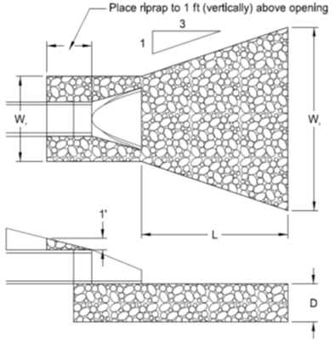
Stations Needing Riprap - Outlet Ends
18" Pipe | 24" Pipe | 30" Pipe | 36" Pipe | 42" Pipe | 48" Pipe | 54" Pipe | 60" Pipe | 72" Pipe | 78" Pipe | 84" Pipe | 90" Pipe
 |  | RP 1.672 |  |  |  | RP 0.587

Appendix A: HY8 Culvert Analysis Reports
Data to include:
- Culvert Summary Tables
- Site info including Site Data with Inverts
- Crossing Summary Table
- Water Surface Profile Plot
- Downstream Channel Rating Curve Data (if applicable)
- Site Data
- Culvert Data
- Tailwater Data
- Roadway Data

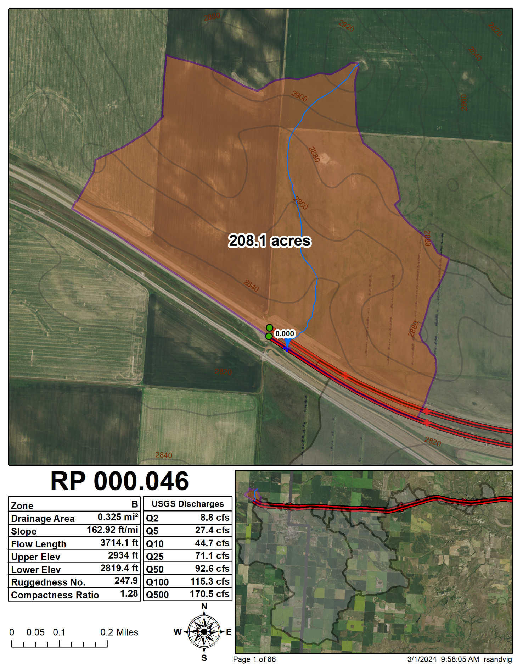
Appendix B: Drainage Areas
Example Map Shown. Map should contain:
- North Arrow
- Highways/Major Roadways labeled with Reference Points shown
- Drainage areas mapped with longest flow path or NHD flowlines depicted
- Contours
- Summary of Calculated Peak Discharges and parameters used, including Hydrologic Zone, Drainage Area, 10/85 Slope (Zone A), Ruggedness No. (Zones B & C), Compactness Ratio (Zone B)
16
94
94

Appendix C: Preliminary Hydraulic Data
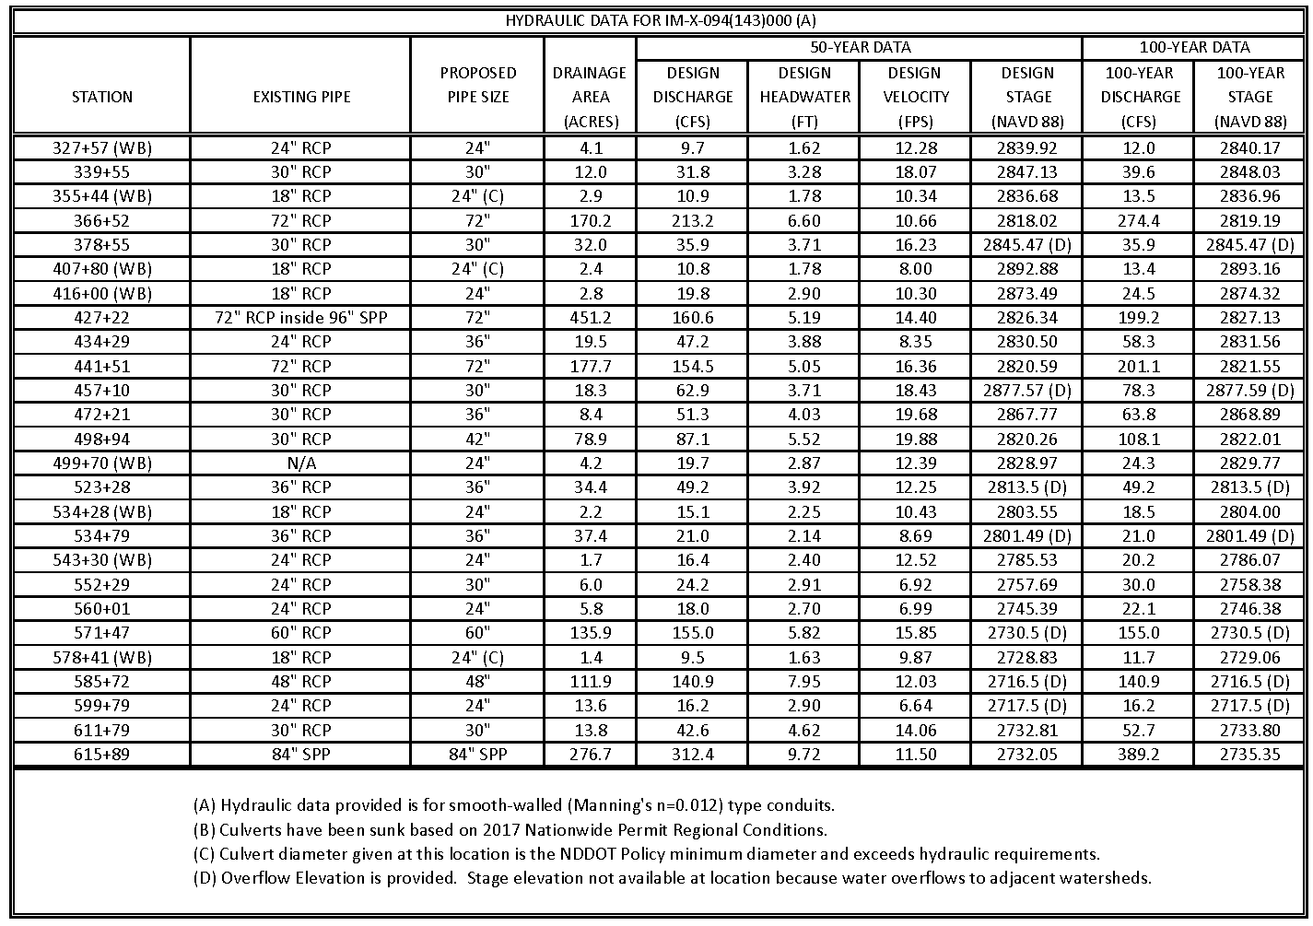
Table of hydraulic data showing culvert stationing, existing and proposed pipes, drainage area size, and design values for discharge, headwater, velocity, and stage, along with 100-year discharge and stage elevations. Table of hydraulic data showing culvert stationing, existing and proposed pipes, drainage area size, and design values for discharge, headwater, velocity, and stage, along with 100-year discharge and stage elevations. Table of hydraulic data showing culvert stationing, existing and proposed pipes, drainage area size, and design values for discharge, headwater, velocity, and stage, along with 100-year discharge and stage elevations. Table of hydraulic data showing culvert stationing, existing and proposed pipes, drainage area size, and design values for discharge, headwater, velocity, and stage, along with 100-year discharge and stage elevations. Table of hydraulic data showing culvert stationing, existing and proposed pipes, drainage area size, and design values for discharge, headwater, velocity, and stage, along with 100-year discharge and stage elevations. Table of hydraulic data showing culvert stationing, existing and proposed pipes, drainage area size, and design values for discharge, headwater, velocity, and stage, along with 100-year discharge and stage elevations. Table of hydraulic data showing culvert stationing, existing and proposed pipes, drainage area size, and design values for discharge, headwater, velocity, and stage, along with 100-year discharge and stage elevations. Table of hydraulic data showing culvert stationing, existing and proposed pipes, drainage area size, and design values for discharge, headwater, velocity, and stage, along with 100-year discharge and stage elevations. Table of hydraulic data showing culvert stationing, existing and proposed pipes, drainage area size, and design values for discharge, headwater, velocity, and stage, along with 100-year discharge and stage elevations. Table of hydraulic data showing culvert stationing, existing and proposed pipes, drainage area size, and design values for discharge, headwater, velocity, and stage, along with 100-year discharge and stage elevations. Table of hydraulic data showing culvert stationing, existing and proposed pipes, drainage area size, and design values for discharge, headwater, velocity, and stage, along with 100-year discharge and stage elevations. Table of hydraulic data showing culvert stationing, existing and proposed pipes, drainage area size, and design values for discharge, headwater, velocity, and stage, along with 100-year discharge and stage elevations. Table of hydraulic data showing culvert stationing, existing and proposed pipes, drainage area size, and design values for discharge, headwater, velocity, and stage, along with 100-year discharge and stage elevations. Table of hydraulic data showing culvert stationing, existing and proposed pipes, drainage area size, and design values for discharge, headwater, velocity, and stage, along with 100-year discharge and stage elevations.

Appendix D: StreamStats (if applicable)
