Appendix B1 May 12, 2014

USACE 404 Jurisdictional Information and Examples

Appendix P

USACE Limits of Jurisdiction Stream Channels

USACE Limits of Jurisdiction Stream Channels



USACE Limits of Jurisdiction Stream Channels

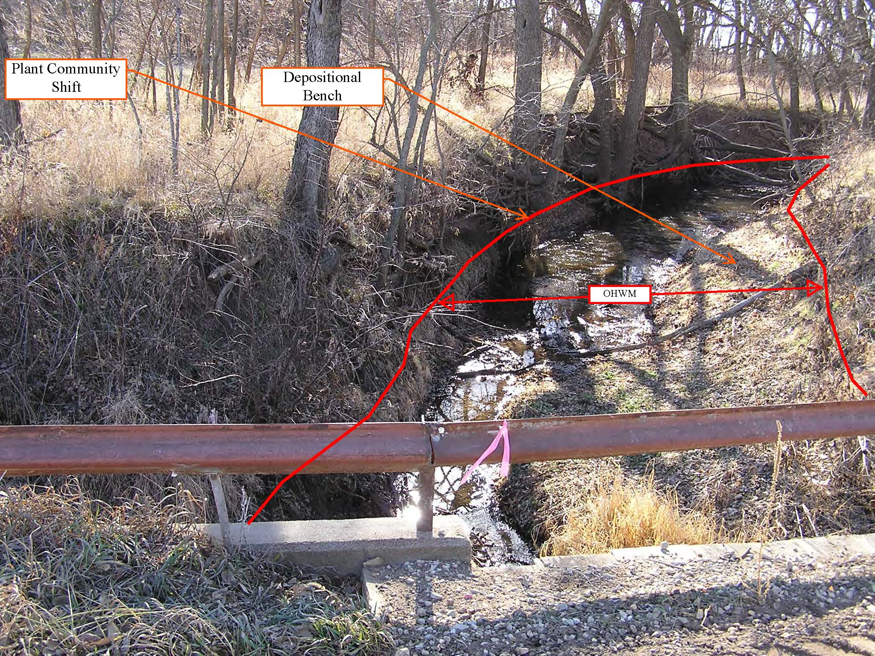

USACE Limits of Jurisdiction Stream Channels

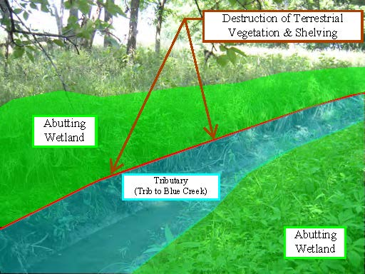

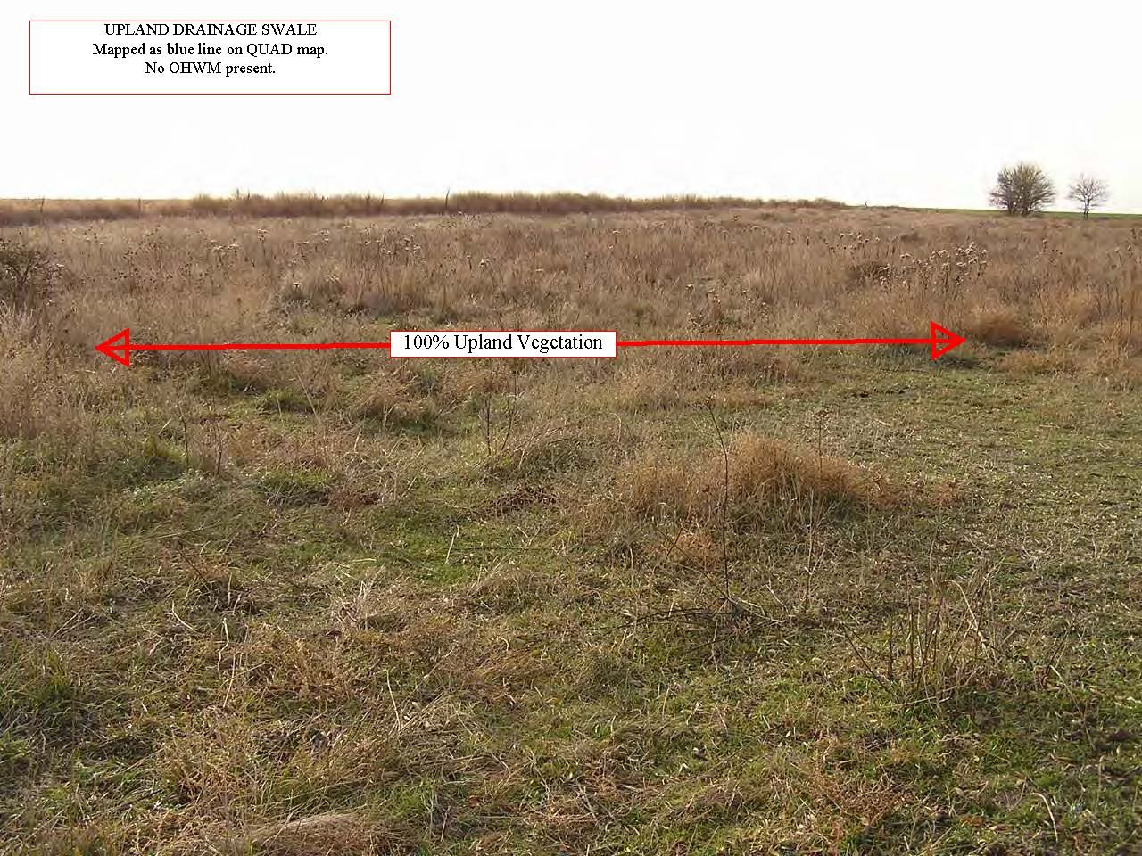

USACE Limits of Jurisdiction Stream Channels

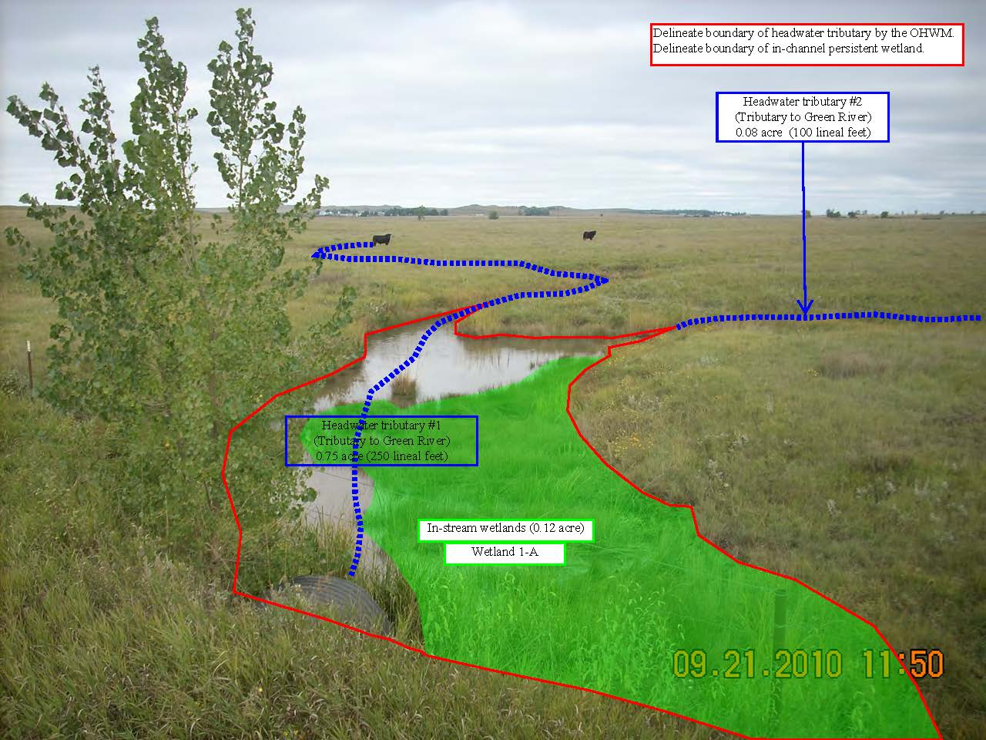

USACE Limits of Jurisdiction Stream Channels

