REQUEST FOR PROPOSAL
August 9, 2022

TO PERFORM
PRELIMINARY ENGINEERING SERVICES
FOR PROJECT:

2-052(050)266, PCN 23630
JAMESTOWN, US-52, 7 ST TO 4 AVE SW

William T. Panos

DIRECTOR

NORTH DAKOTA DEPARTMENT OF TRANSPORTATION

PROPOSALS MUST BE DELIVERED TO
ANDY AYASH
ENVIRONMENTAL AND TRANSPORTATION SERVICES DIVISION
By
12:00 PM Central Time August 30, 2022

REQUEST FOR PROPOSAL

PROJECT OVERVIEW

The North Dakota Department of Transportation (NDDOT) is requesting the services of a qualified engineering consultant to perform engineering and affiliated services to complete the following project.

Project 2-052(050)266, PCN 23630, Jamestown, US-52, 7th Street to 4th Avenue. See project location map below.
2-052(050)266
Project Location Map
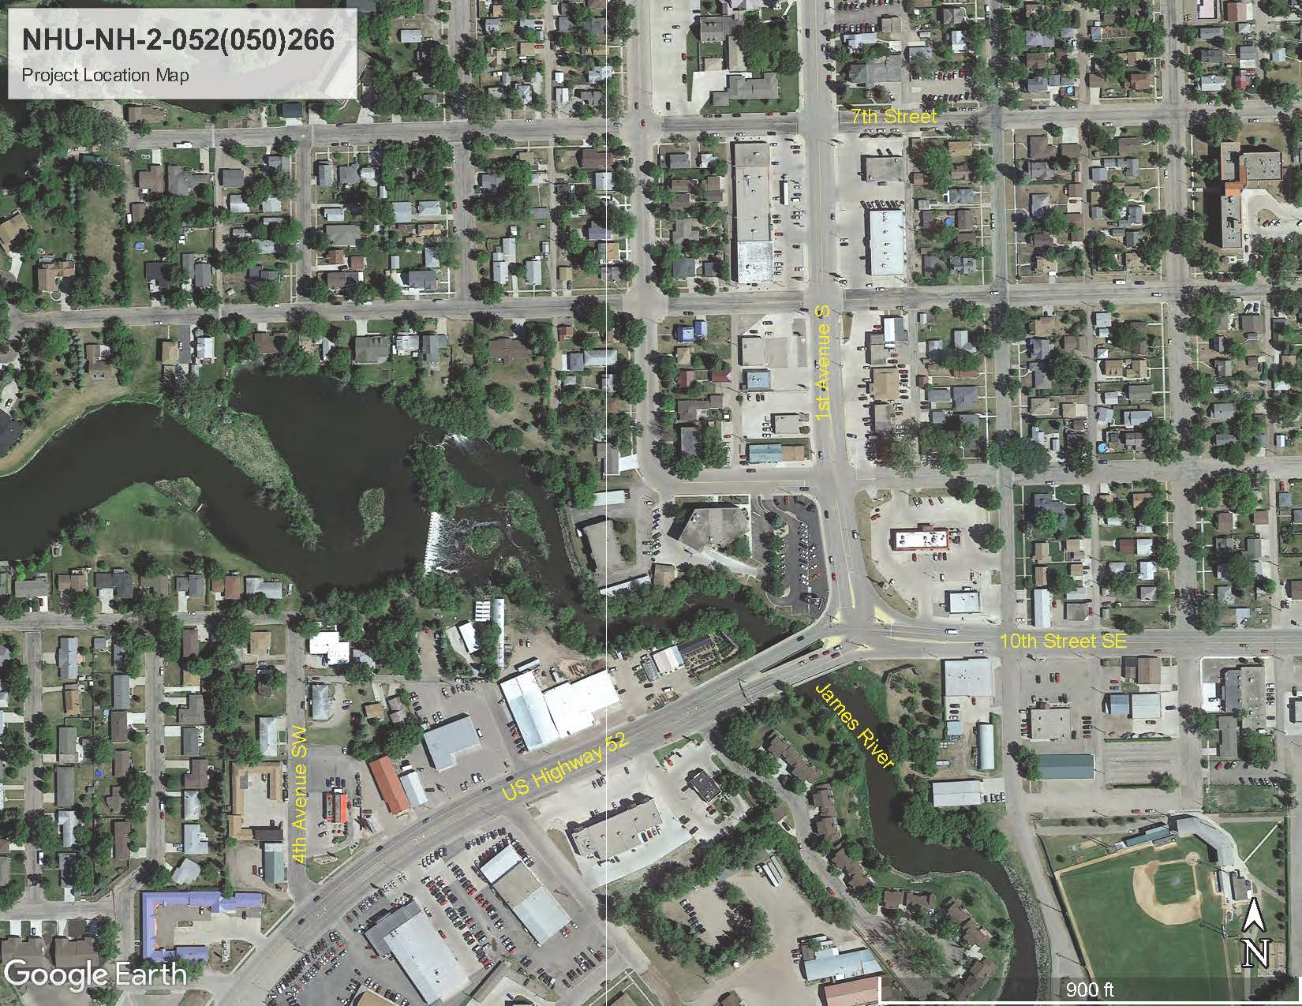

SCOPE OF SERVICES

NDDOT is requesting roadway design and bridge design services for all work necessary to provide environmental studies and documentation, preliminary engineering and design, final design, permitting, right of way acquisition, and construction plans for the above stated project.

NDDOT intends to execute one cost plus fixed fee contract for each project requiring monthly billings. NDDOT reserves the right to assign work in phases and have the consultant selected perform any additional work not currently assigned. Project work items may be added or removed from the contract by work authorization or supplementary agreement.

PROJECT DESCRIPTION AND DELIVERABLES
The project was submitted by the City of Jamestown for reconstruction of US Highway 52 from the James River bridges extending west to 4th Avenue Southwest. Local Government Division, coordinated with Bridge Division to determine future work required on the bridges. It was determined that the two bridges (#0281-068.593 L and #0281-068.596 R) over the James River require replacement. The bridge replacements will be completed concurrently with City of Jamestown reconstruction.

Because of the proximity of the intersection, between 1st Avenue South and 10th Street Southeast, just east of the bridges, it was also determined to include an analysis for the reconfiguration of this intersection with this project and the limits were extended from 7th Street to 4th Avenue Southwest, and to a tie-down point on 10th Street Southeast.

In addition to the scope of work identified in the City’s Scoping Worksheet, this project will include:

- Replacement of the James River structures (#0281-068.593 L and #0281-068.596 R)
- Reconstruction of the intersection of 1st Avenue S (US Highway 52) and 10th Street SE
- Paving marking changes on 1st Avenue S between the intersection reconstruction and 7th Street will also be made to transition to the road diet section occurring to the north on 1st Avenue South

Phase I, Scoping: Phase I shall be limited to conducting a scoping meeting, field review, initial preliminary survey and developing a NDDOT approved scope of work and hours for Phase II.

The Engineer will have 30 days, from the date that the Phase I contract is executed, to conduct the scoping meeting, field review and secure an approved scope of work and hours. A preliminary scope of work and hours shall be provided by the consultant within 21 days of signing the contract. Pending NDDOT approval of the scope of work and hours completed in Phase I, the NDDOT may authorize the Engineer to perform Phase II and any additional work not currently assigned or completed in Phase I.

Phase II, Environmental Document and Preliminary Design: Phase II shall consist of all activities necessary to complete the environmental document (including FHWA concurrence and approval), conduct public involvement, perform preliminary design, and coordinate utility location and conflict plans. Phase II will be considered complete upon receiving environmental approval from FHWA and NDDOT approval of all other deliverables. Phase III may be negotiated and authorized based on the outcome of Phase II, Engineer’s proposal, Engineer’s performance, and available funding.

Phase III, Final Design: Phase III shall consist of design activities following preliminary design and preparation of final construction plans, specifications, and estimates; execution of contracts for utility conflict plans, adjustments, and relocations; final right of way acquisition, final mitigation plans and permitting. Phase III will be considered complete upon delivery and approval of final construction plans, specifications, estimates, certifications, and NDDOT approval of all other deliverables. Phase IV may be negotiated and authorized based on the outcome of Phase III, Engineer’s proposal, Engineer’s performance, and available funding.

Phase IV, Engineer of Record: Phase IV, if necessary, shall consist of engineering services associated with Engineer of Record activities including, but not limited to, consultation and questions, pre-job meetings, plan revisions & change orders, and shop drawings. Phase IV does not include construction engineering.

Consultants interested in performing the work must be qualified to perform roadway and structural design.

Interviews will be conducted tentatively 30 days from the due date of this proposal.

Attached with the RFP are the Milestone Reports, Decision Document, and Risk Management Appendix.

All design and project data will become the property of NDDOT upon completion of the final submittal. All project information will be generated in the following formats and standards:

- MS Word and MS Excel
- MircoStation connect edition (10.16…)
- OpenRoads Designer CE (10.10.21.04)
- NDDOT CADD Manual
- Microsoft “Project”
- NDDOT Consultant Services Manual Chapter 19
- NDDOT Procedure for Creating Right of Way Plats Manual Chapter 20
- NDDOT CADD Editing Manual Chapter 21
- NDDOT Data Collection Codes and Procedures
- NDDOT Design Manual and Plan Preparation Guide Website
- NDDOT Right of Way Manual
- Adobe Acrobat (standard or compatible)

PROJECT SCHEDULE
The project shall be completed on or before the Bid Ready Date of May 1, 2026. (see milestone report)

PROPOSED SUB CONSULTANT REQUEST

Sub Consultant firms that have been contacted and agree to be listed on the Prime Consultants Project Proposal for work with NDDOT must submit original form and one copy to be attached to the Prime Consultants Proposal. This form is used for informational purposes only. See NDDOT web site for form SFN 60232. (http://www.dot.nd.gov/dotnet/forms/forms.aspx )

PRIME CONSULTANT REQUEST TO SUBLET

The successful consultant will be required to include the attached ‘Prime Consultant Request to Sublet’ form for each Sub consultant listed on the contract prior to execution of the contract. The form assures that the contract between the Prime consultant and all Sub consultants contains all the pertinent provisions and requirements of the prime contract with the North Dakota Department of Transportation (NDDOT). See NDDOT web site for form SFN 60233. http://www.dot.nd.gov/dotnet/forms/forms.aspx
If the Prime consultant has a DBE as a sub-consultant then they will also be required to submit SFN 61412-DBE Consultant-Commercially Useful Function (CUF) https://www.dot.nd.gov/forms/sfn61412.pdf

CIVIL RIGHTS

The North Dakota Department of Transportation, in accordance with the provisions of Title VI of the Civil Rights Act of 1964 (78 Stat. 252, 42 US.C.§§ 2000d to 2000d-4) and the Regulations, hereby notifies all bidders that it will affirmatively ensure that any contract entered into pursuant to this advertisement, disadvantaged business enterprises will be afforded full and fair opportunity to submit bids in response to this invitation and will not be discriminated against on the grounds of race, color, or national origin in consideration for an award.

Disadvantaged Business Enterprise (DBE)
49 Code of Federal Regulations Part 26 (CFR) states that the consultant, sub recipient, or sub consultant shall not discriminate on the basis of race, color, national origin, or sex in the performance of this contract. Consultants shall carry out applicable requirements of 49 CFR Part 26 in the solicitation, award, and administration of USDOT-assisted contracts. Failure by the consultant, to carry out these requirements is a material breach of the contract, which may result in the termination of the contract or such other remedy as the recipient deems appropriate. For information regarding the DBE Program, see the DBE Program Manual at http://www.dot.nd.gov/divisions/civilrights/docs/dbe/dbe-program-admin-manual.pdf

Title VI/Nondiscrimination and ADA
Title VI assures that no person or group of persons may, on the grounds of race, color, national origin, sex, age, or disability, be excluded from participation in, be denied the benefits of, or be otherwise subjected to discrimination under any and all programs or activities administered by the Department. For information regarding Title VI, see the Title VI/Nondiscrimination and ADA Program at https://www.dot.nd.gov/divisions/civilrights/docs/titlevi/Title-VI-Nondiscrimination-ADA-Program-Implementation-Plan.pdf

The two paragraphs above apply to every consultant on the project, including every tier of sub consultant. It is the consultant’s, or sub consultant’s responsibility to include the two above paragraphs in every subcontract.

RIGHT OF WAY (If needed)

Scope of Work
Project Coordination
- Prior to commencing valuation work, a preliminary meeting will be held with the consultant and the NDDOT Review Appraiser. A Preliminary Valuation Review form must be completed for every project requiring an Appraisal, Waiver Valuation, Short Form Report and/or Basic Data Book.
http://www.dot.nd.gov/forms/sfn61346.pdf

- Prior to commencing initial right of way work, a preliminary meeting will be held with the consultant, sub consultant (negotiator), NDDOT ROW tech support, NDDOT Design tech support, NDDOT Designer and any additional participants as needed. This will include reviewing forms, package submission, process review and reporting requirements.

Consultant’s proposal
Appendix
Any consultant or sub consultant performing right of way acquisition negotiations must submit a biography, including a certificate of completion for the following class:

FHWI – NHI Course # 141045, Real Estate Acquisition under the Uniform Act: An Overview
(https://www.nhi.fhwa.dot.gov/training/course_search.aspx?sf=0&course_no=141045)

Please refer to the attached biography as a referenced example.
https://www.dot.nd.gov/divisions/environmental/docs/RFP%20Biography.pdf

EVALUATION AND SELECTION PROCESS

Consultants interested in performing the work must submit one electronic copy in PDF format. The electronic copy must be submitted prior to the date and time listed on the cover of this RFP to be considered. Late proposals will not be considered.

Proposals shall be submitted by email to:

Andy Ayash aayash@nd.gov with copies to Ron Peck at rjpeck@nd.gov and Joy Glasoe jglasoe@nd.gov

- Each proposal shall contain a cover letter signed by an authorized officer who can sign contracts for the consultant. The pages of the cover letter will not be counted as a part of the pages. Also include the individuals email address below each signature on the cover letter.

- The proposal pages shall be numbered and must be limited to 5 pages in length. Proposals that exceed the page length requirement will not be considered. This section should contain your approach and project specific plan.

- The consultant’s proposal shall include an appendix. The appendix may include updated Federal form 330 if you do not have one on file with CAS. The pages in the appendix will not be counted as a part of the pages. The appendix shall include the following in this order:

Appendix A
  - A schedule for the project. If accepted the schedule will be included as part of the contract.
Appendix B
  - A staffing plan identifying the key project personnel (including titles, education, and work experience) and the respective roles and responsibilities for the project.
Appendix C
  - Project Specific QC/QA Plan including check lists, persons, responsibilities, proposed submittals and reviews, and DOT response timelines. The QC/QA Plan will be reviewed by the NDDOT and, if accepted, become part of the project after the contract has been signed.
Appendix D
  - Sub-consultants and associated activities to be completed by the sub-consultants. Attach proposed sublet form SFN 60232 for each sub at the end of this section.

Each proposal will be evaluated by a selection committee consisting of NDDOT staff members and/or representatives. NDDOT reserves the right to limit the interviews to a minimum of three consultants whose proposals most clearly meet the RFP requirements. Consultants not selected to be interviewed will be notified in writing.

Selection will be on the basis of the following weighted criteria:

Weight

- __10%___ i. Past performance
- __10%___ ii. Ability of professional personnel
- __10%___ iii. Willingness to meet time and budget requirements
- __10%___ iv. Location
- __10%___ v. Recent, current, and projected workloads of the persons and/or consultants
- __10%___ vi. Related experience on similar projects
- __10%___ vii. Recent and current work for the agency
- __30%___ viii. Project understanding, issues, and approach
- __5%_ ix. DBE: Up to 5 points may be awarded for good faith efforts to utilize DBE’s in case of tied scores

Weights for each criteria are assigned independently for each specific project by CAS and the
Project Technical Representative. Maximum total weight is 100 points. 5 additional points
may be awarded for good faith efforts to utilize DBE’s in the event of a tie.

Consultants are strongly encouraged to use DBE sub consultant services where applicable. The proposal must contain a list of any tasks that may be let to sub consultants should the consultant be awarded the contract. It must also contain the specific good faith efforts made by the consultant, to achieve DBE participation, in the areas intended for sub-consulting. Consultant interviews will include questions regarding good faith efforts (see 49 CFR Part 26, Appendix A: Guidance Concerning Good Faith Efforts, Paragraph IV. A-H) to achieve DBE participation. DBE participation will be a consideration during the negotiation stage of each contract.

PROMPT PAYMENT

Consultants will be required to make prompt payment to subconsultants as required by 49 CFR 26.29. The Consultant shall make payment to all subconsultants within thirty (30) calendar days from receipt of payment from the State. Such payment shall be certified by the Consultant by submittal of the subsequent Consultant Contract Billing Form to the State. The State may withhold subsequent payment(s) to the Consultant if any subconsultants have not been paid for work satisfactorily completed.

RIGHT OF REJECTION

The North Dakota Department of Transportation reserves the right to reject any or all proposals.

DISCLOSURE OF PROPOSAL

At the conclusion of the selection process, the contents of the short-listed proposals will be subject to North Dakota's Open Records Law and may be open to inspection by interested parties. Any information included in the proposal that the proposing party believes to be a trade secret or proprietary information must be clearly identified in the proposal. Any identified information recognized as such and protected by law may be exempt from disclosure.

RISK MANAGEMENT FOR PROFESSIONAL SERVICES

The Risk Management Appendix/Addendum will be incorporated into the agreement between NDDOT and the consultant. Consultants must be able to provide a proper Certificate of Insurance within 15 days of notification of Selection.

AUDIT

Consultants proposing to do work for the NDDOT must have a current audit rate no older than 12 months from the close of the consultant’s Fiscal Year. Consultants that do not meet this requirement will not qualify to propose or contract for NDDOT projects until the requirement is met. Consultants that have submitted all the necessary information to the NDDOT and are waiting for the completion of the audit will be qualified to submit proposals for work. Information submitted by a consultant that is incomplete will not qualify. Out of state consultants can submit a current accepted FARS audit rate from a cognizant agency. Under certain conditions NDDOT may offer a Safe Harbor Rate of 110% to consultants that do not have a compliant rate.

CONSULTANT EMAIL CONTACTS

If necessary, please update contact information for receiving RFP's via email

