H & H Technical Memorandum
NDDOT | Project, PCN or ND XX, RP XXX.XX

TO: Monte Deis, PE
NDDOT Bridge Division

FROM: Name,
Title or Consultant

DATE: Month XX, XXXX

SUBJECT: Hydrologic and Hydraulic Analysis

LOCATION: HWY, RP (If on the State Highway System) or County Rd
Legal Description

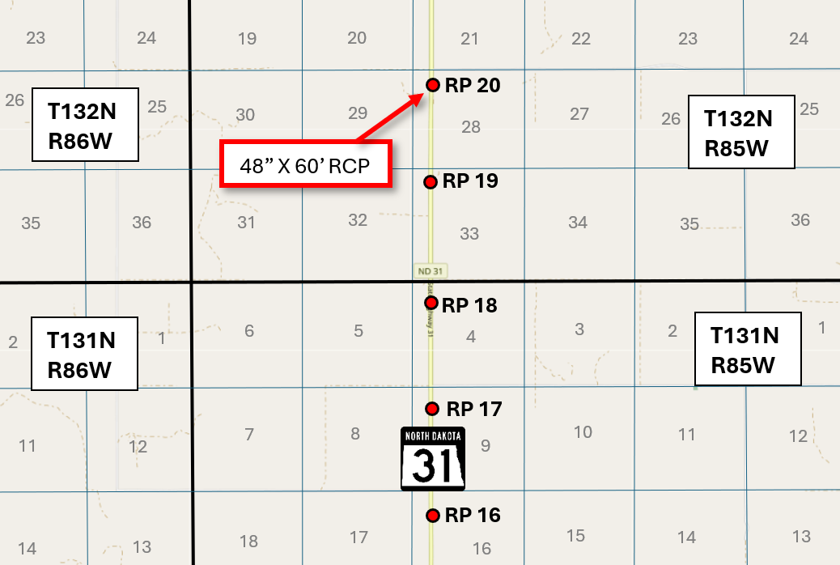
Figure 1 – Location Map

Introduction
This technical memorandum summarizes the hydrologic and hydraulic analysis performed for the existing culvert(s) at location. This analysis will describe the methods used to determine the existing hydraulic capacity as well as potential replacement of the culvert(s).

Methodology
The crossing(s) lie(s) within USGS Hydrologic Zone X for North Dakota. In accordance with the NDDOT Design Manual Section (ie. V-01.04), the Regression Equations from the United States Geological Survey (USGS) Report, “Scientific Investigations Report 2015-5096: Regional Regression Equations to Estimate Peak-Flow Frequency at Sites in North Dakota Using Data through 2009”, were used to calculate the peak flows. This technique uses regression equations developed from stream gaging stations to determine the peak runoff for a specified runoff event. The contributing drainage areas were manually delineated for each crossing using (ArcGIS/GIS software, topographic maps, LiDAR data, etc) with StreamStats used solely as a reference (delete as applicable). The stream lengths were determined from (longest flow paths, NHD flowlines, etc).

Minimum Flood Frequency
The minimum design flood frequency requirements as per Article 89-14 of the North Dakota Administration Code (ND Stream Crossing Standards) are shown below in Figure 2. Based on the functional classification of (insert classification) for Highway ##, a XX-year recurrence interval was used for the hydraulic analysis.

Figure 2 – Minimum Design Flood Frequency

Hydraulic Analysis/Recommendations
The crossing(s) was/were evaluated using FHWA’s HY-8 Software, Version #.# and analyzed for compliance with ND Stream Crossing Standards. A summary of the results and recommendations are provided below.
ND Hwy 31, RP 20.045
The streambed slope at the crossing was estimated to be #.## feet per mile. As per the requirements stated in ND Stream Crossing Standards, the existing ##” diameter culvert was evaluated with an allowable headwater of (1 pipe diameter plus 2 feet, 1.5 pipe diameters, 2 pipe diameters), or #.## feet. For centerline crossings only: The existing culvert was also checked to ensure the crossing could adequately convey the 100-year discharge without overtopping of the roadway. For approach crossings only: The existing culvert was also checked to ensure that the headwater developed upstream from the approach does not result in flooding of the mainline highway at the mainline’s design flood frequency event (e.g. 25 or 50-year).

The calculated headwater at the ##-year design event for the existing culvert is #.## feet, which satisfies the allowable headwater requirements from the ND Stream Crossing Standards. The design outlet velocity of the culvert was found to be #.## ft/s. For centerline crossings only: The headwater elevation at the culvert was also checked at the 100-year discharge and found to be ####.## feet, which is below/above the overtopping elevation of the highway of ####.## feet. For approach crossings: The headwater elevation at the approach was also checked at the (mainline highway’s peak discharge, e.g. 25 or 50)-year discharge and found/not found to result in overtopping of the mainline highway. A table of the results is shown below in Table 1.
OR:
The calculated headwater at the ##-year design event for the existing culvert is #.## feet, which exceeds allowable headwater requirements. To satisfy ND Stream Crossing Standards, it is recommended that the existing culvert be replaced with a ##” diameter culvert. If the existing culvert is to remain, an additional ##” diameter culvert would need to be installed adjacent to the existing ##” diameter culvert to satisfy ND Stream Crossing Standards. A summary of the results is shown below in Table 1.
Table 1 – Hydraulic Calculation Summary
Location/  Description | Culvert | Drainage Area (acres) | Design-Year Data |  |  |  |  | Max-Year Data
 |  |  | Design Discharge (cfs) | Allowable Headwater (feet) | Design Headwater (feet) | Design Velocity (ft/s) | Design Stage (feet) | Max-Year Discharge (cfs) | Max-Year Stage (feet)
RP 20.045 (Existing) | 48”x60’ RCP | - | - | - | - | - | - | - | -
RP 20.045 (Proposed) | 54” RCP | - | - | - | - | - | - | - | -
RP 20.045 (Existing + Added Pipe) | 48”x60’ RCP | - | - | - | - | - | - | - | -
 | 30” RCP |  |  |  |  | -
Update the table headings with the appropriate Design-Year and Max-Year events from the guidance on Minimum Flood Design Flood Frequency, and fill in the corresponding data. For centerline crossings, Design Year is typically 25-year for all State/US Highways, and 50-year for Interstate, while Max Year refers to the 100-year event. For approach crossings, Design Year is typically either the 10-year or 15-year event depending on the classification of the roadway, while the Max Year event refers to the design flood frequency event for the adjacent mainline highway.

Modify or add to the paragraphs above noting any unique circumstances or other critical hydraulic information. Note the outlet velocities at the culverts and whether riprap is recommended as a scour countermeasure.

HY-8 Culvert Analysis Reports

Data to include:
- Culvert Summary Tables
- Site info including Site Data with Inverts
- Crossing Summary Table
- Water Surface Profile Plot
- Downstream Channel Rating Curve Data (if applicable)
- Site Data
- Culvert Data
- Tailwater Data
- Roadway Data

StreamStats Output

Drainage Areas
