Appendix B4 – Wetland Classification Illustrations and Charts May 12, 2014

Illustration of Riverine Wetland System

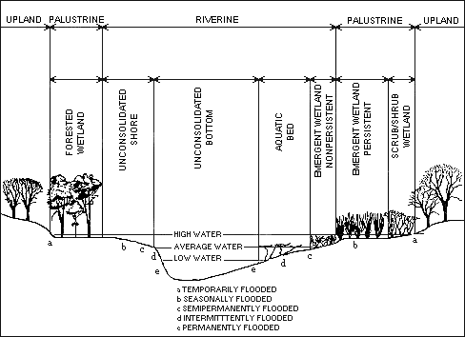
From Cowardin, et al.

Illustration of Palustrine Wetland System

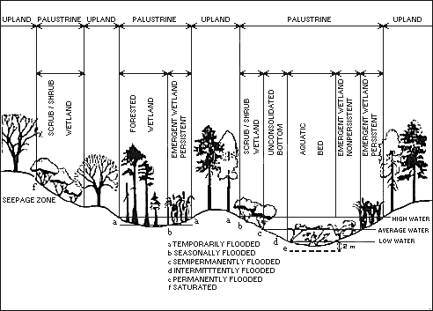
From Cowardin, et al.

Illustration of Lacustrine Wetland System

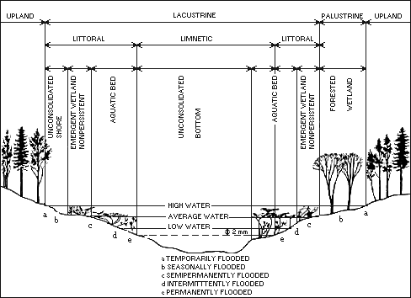
From Cowardin, et al.

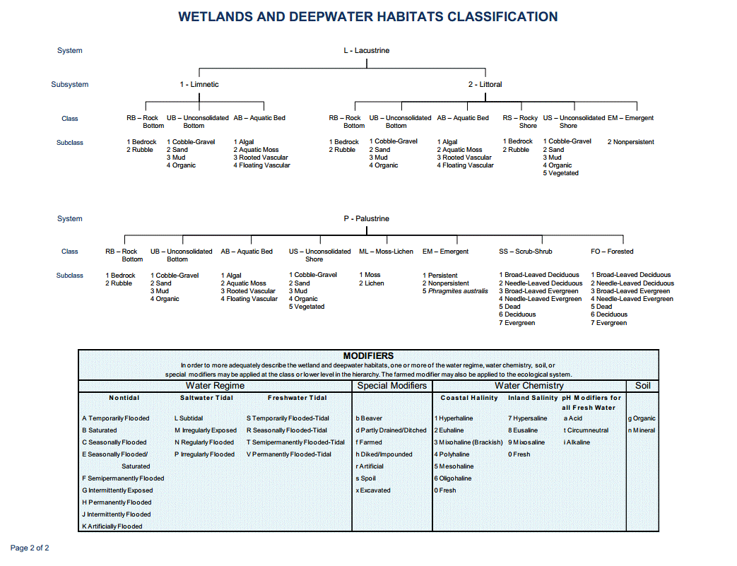
From Cowardin, et al.

