NORTH DAKOTA DEPARTMENT OF TRANSPORTATION (NDDOT)
129,000 POUND LARGE TRUCK PRIMARY HIGHWAY NETWORK ADVISORY COMMITTEE

10/30/2017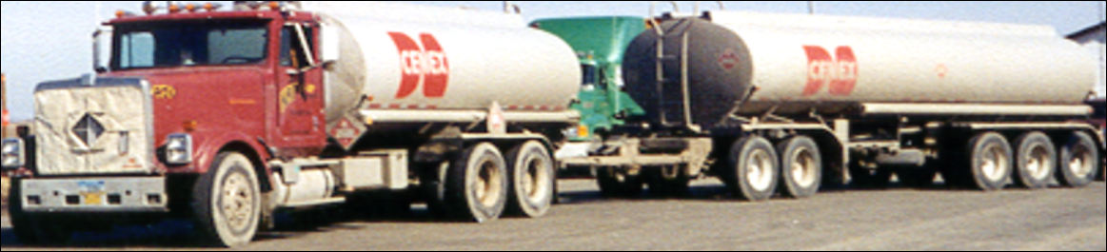

Charter

This Charter is developed based on the requirements of 2017 House Bill 1255.

Sixty-fifth Legislative Assembly of North Dakota

HOUSE BILL NO. 1255
(Representatives D. Ruby, Owens, Weisz)
(Senators Campbell, Laffen)

AN ACT to create and enact a new chapter to title 24 and a new subsection to section 39-12-05.3 of the North Dakota Century Code, relating to the creation of a large truck primary highway network and the permitting of increased vehicle weights.

BE IT ENACTED BY THE LEGISLATIVE ASSEMBLY OF NORTH DAKOTA:
SECTION 1. A new chapter to title 24 of the North Dakota Century Code is created and enacted as follows:

Primary network.
The department of transportation shall establish a limited transportation network within this state. The initial network consists of selected highways and the interstate system to serve as the foundation for this system. The department may modify the foundation through a public involvement process established by the department. The foundation for the system consists of:
1. United States highway 83 from the South Dakota border to Minot;
2. United States highway 85 from the South Dakota border to Williston;
3. United States highway 52 from Minot to the Canadian border;
4. United States highway 2 from the Montana border to the Minnesota border;
5. Interstate highway 94 from the Montana border to the Minnesota border, subject to federal
approval; and 6. Interstate highway 29 from the South Dakota border to the Canadian border, subject to federal approval.

Process for modification.
1. The department of transportation shall establish a process to adjust the network by adding
specific segments of the United States or state highway system. The process must include an
advisory committee to provide input to the department in actions taken to adjust the system,
taking into consideration the economic needs and benefits, investment and maintenance
requirements, and safety.

2. The department shall establish a request mechanism for commercial entities and for
individuals who reside in the state to request specific augmentations of the system based on
economic need and outcomes.

Advisory committee.
1. The advisory committee must be chaired by the director of the department of transportation or
a designee of the director and must consist of a representative appointed by:

- The greater North Dakota chamber;
- The North Dakota association of counties;
- The agriculture commissioner;
- The commerce commissioner;
- The superintendent of the highway patrol;
- The North Dakota motor carriers association;
- The North Dakota league of cities; and
- Representatives of short line railroads operating in this state.

2. The committee may be augmented by the department as deemed necessary in consultation
with the advisory committee.

Conditional approval for interstate highway system within North Dakota.
The department may include the interstate highway system within the state as part of the primary foundation network if approved through passage of legislation by the Congress of the United States.

Authority to establish truck axle configuration and weight limits associated with the one
hundred twenty - nine thousand pound network.
Notwithstanding any other provision of law, the department of transportation, in consultation with
the advisory committee, may adopt rules to establish the required axle configurations and weight limit requirements for trucks weighing more than one hundred five thousand five hundred pounds [47854 kilograms] utilizing the network established by this chapter.

Preservation of existing truck weight provisions.
This chapter does not modify or authorize any change to the existing weight limitations for trucks with gross vehicle weight up to one hundred five thousand five hundred pounds [47854 kilograms].

SECTION 2. A new subsection to section 39-12-05.3 of the North Dakota Century Code is created and enacted as follows:

The director may issue a permit for a truck with a gross weight that exceeds one hundred five
thousand five hundred pounds [47854.00 kilograms], not to exceed one hundred twenty nine
thousand pounds [58513.41 kilograms]. The monthly permit fee is one hundred dollars per
month or seven hundred dollars annually. Vehicle weight under this subsection is determined
according to the formula under subsection 2 of section 39 - 12 - 05.

______________________________________________________________________
Roles and Responsibilities
The primary role of the 129,000 Pound Truck Route Committee (hereinafter, the Committee) is to provide advice and recommendations to the NDDOT Director regarding additons and deletions to routes submitted to be considered for the 129,000 pound network created by North Dakota Century Code 24-18. The Committee may consider any information it deems appropriate in its formal recommendations. However, the Committee is not expected to perform research or other information gathering, but rather request the Technical Advisory Council gather any additional information it may require. In addition, the Committee may recommend additions or deletions to the 129,000 pound network and to the processes NDDOT uses to review proposed changes. Ultimate authority for any such network or process changes lies with the NDDOT Director.

Membership
Last updated October 30, 2017
Chairman
Brad Darr – NDDOT State Maintenance Engineer

Advisory Committee
Ron Henke NDDOT Chief Engineer
Brent Bogar North Dakota Chamber of Commerce
Doug Goehring North Dakota Agriculture
Jay Schuler North Dakota Department of Commerce
Capt. Eldon Mehrer North Dakota Highway Patrol
Jason Benson North Dakota Association of Counties
Daniel Zink Shortline Railroads
Chuck Steffan North Dakota Motor Carriers Association
Lance Meyer League of Cities

- The Shortline Railroad representative is on the committesto make sure the impact to competing interests are considered.

NDDOT Technical Advisory Council (Attend all meetings to answer questions)- Non -voting
Jackie Darr North Dakota Highway Patrol
Jon Ketterling NDDOT Bridge Engineer
Gary Doerr NDDOT Bridge Maintenance Structural Team Lead
Jason Thorenson NDDOT Assistant Bridge Engineer
Roger Weigel NDDOT Design Engineer
Derek Pfiefer NDDOT Assistant Design Engineer
Justin Schlosser NDDOT Design
Tom Bold NDDOT Materials and Research
Scott Zainhofsky NDDOT Planning and Asset Management

Meeting rules

Committee meetings
Meetings will be on an as needed basis.
Meetings will follow Robert’s Rules of Order.
In person meetings are preferred. Accommodations will be made to allow participation by phone.
Individual Meeting substitutions are allowed. Prior notice to the NDDOT Maintenance Division of any substitutions is requested at 701-328-2545.
Minutes will be taken
Prefer Quarterly meetings with packets submitted to the committee 30 days prior to the scheduled meetings, anything received after the 30 day mark will be reviewed at the next quarterly meeting.

Committee Additions
The Director has authority under the law to add additional members to the committee. The committee may submit ideas through a formal vote. The director will submit prospective additions to the committee for formal or informal comment, as the committee deems appropriate.

Rule Adoption by NDDOT
As noted in the law above, the NDDOT shall establish a process to adjust the network and may draft rules:

Notwithstanding any other provision of law, the department of transportation, in consultation with the advisory committee, may adopt rules to establish the required axle configurations and weight limit requirements for trucks weighing more than one hundred five thousand five hundred pounds [47854 kilograms] utilizing the network established by this chapter, both for criteria that will be used in assessing the suitability of any nominated stretch of road and for the public participation process in considering any proposed designation.

Safety must be the highest priority, addressing necessary and prudent restrictions on use of designated routes, enforcement processes from jurisdiction to jurisdiction, mechanical requirements for trucks and trailers, driver certification requirements, pavement and roadbed conditions, bridge conditions and load carrying capacities, geographic conditions, weather conditions, possible restrictions caused by horizontal and vertical alignment, and other factors unique to each area in question. The process of considering nominated routes also must include timely, well-noticed public involvement and potentially notification of adjacent property owners. (This does not mean that adjacent property owners will receive individual notification. Notification will be provided via legal notices and information posted on the 129,000 Pound Truck Route website.)

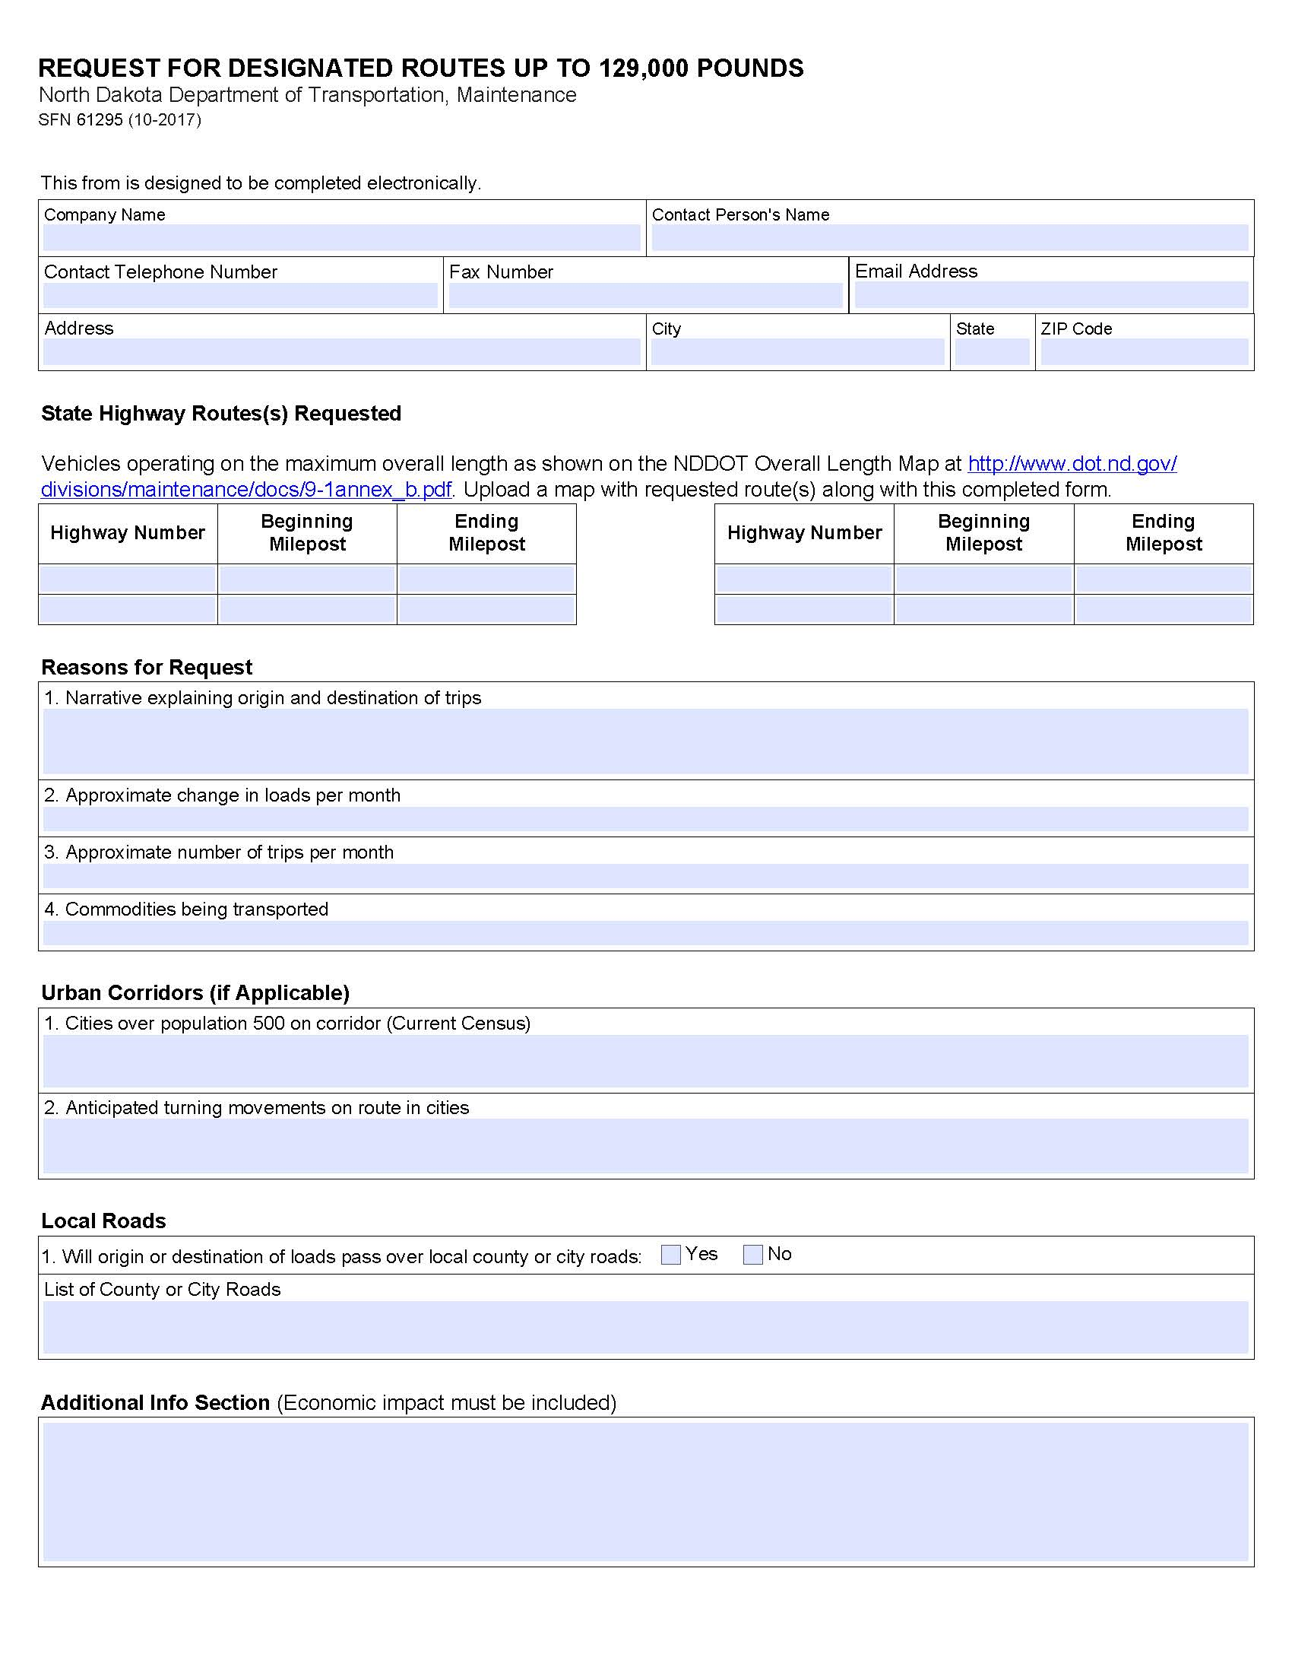
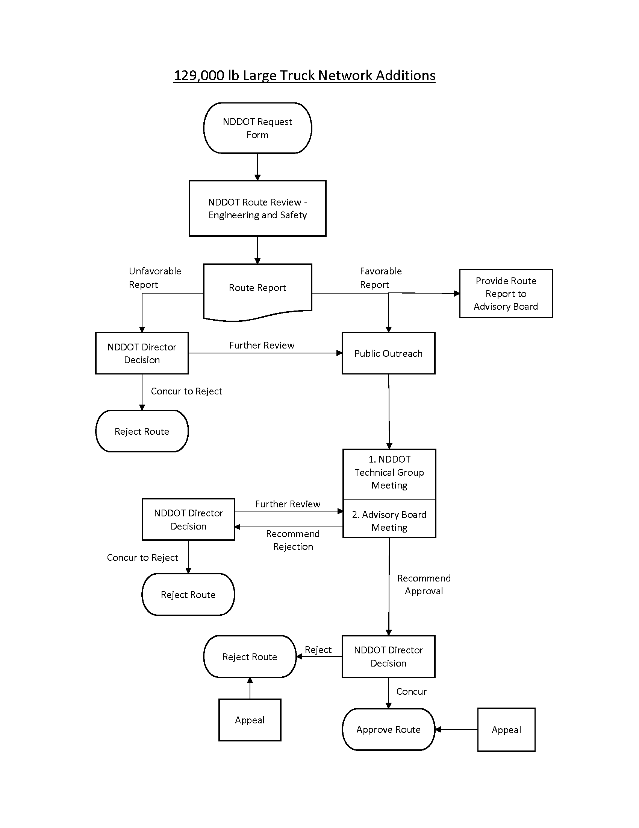

- NDDOT Request Form Submission: Request Form SFN 61295 will be completed and submitted to the North Dakota Department of Transportation Maintenance Division
by the requestor (applicant). The NDDOT or Applicant will forward to the adjacent (contiguous) local jurisdictions in accordance with guidance on SFN 61295.

- Review / Analysis: Following submission of SFN 61295, the request will be reviewed for completeness. If is incomplete, it will be returned to the applicant with an explanation for returning the form. If the form is complete, the department’s analysis for engineering and safety criteria will commence. Analysis criteria shall include assessment of pavement and bridges to allow legal tire, axle, and gross weight limits. Additional consideration shall be given to traffic volumes and other safety factors. A route report will be created.

- Public outreach: Once the analysis is complete, the NDDOT will finalize a report on the application. If the report is favorable toward the application, public outreach will be scheduled to gather public testimony. A summary of the report will be provided to the Division/District who will conduct the hearing. The summary report will also be posted on the NDDOT 129,000 Pound Truck Route website. If more than one route has been requested in a district, one hearing may be held to gather testimony on all of the routes in that district. If the report is not favorable toward the application, the NDDOT will present the findings to the 129,000 Pound Truck Route committee for its consideration.

Public outreach could include a matrix such as this.

All routes should have a formal letter sent to the county commissions that will be affected.

All routes affecting cities over 500 should have a letter soliciting comments from the cities affected.

Get comments through website. Individuals could sign up for push notifications using gov delivery.

At what point is a public hearing necessary? Passes by a City greater than 500 or 5000. Any route? Public hearing held in county seat of most populous county/ multiple public hearings. Areas affecting Short line railroads.

What advertising requirements should there be? When published in the paper which papers? Definitely send out a news release.

- NDDOT Technical Advisory Council: The NDDOT will present findings and relevant information to the 129,000 Pound Truck Route committee along with a recommendation to approve or reject the application based on a completed review of engineering and safety criteria.

- Advisory Board Meeting: Committee meetings will be open meetings without additional public testimony; however, comments received up until the published closing date will be considered and specifically addressed by the chair of the committee The Chair will present the analysis of the route(s) and a recommendation for committee action. After discussions, if the report is favorable, the voting committee members shall vote on a motion to hold the request for additional information or recommend the Director reject or approve the application. Minutes of committee meetings will be taken and posted on the NDDOT 129,000 Pound Truck Route website.

- NDDOT Director Decision: The Director will take all available information into account and make a decision. The Decision will be posted on the NDDOT 129,000 pound Truck Route Website. Does the Director want to limit the network in anyway up front?

- Appeal Process: If applicant is not satisfied with the Directors Decision and more information is available a letter of appeal may be sent to the Director.

